**58th ANNUAL REPORT 2019**

HARVARD CLUB OF AUSTRALIA INC

ABN 70 814 606 610

and its subsidiary

HCA PHILANTHROPY PTY LTD

ABN 93 091 483 635

Patron – Sir James D Wolfensohn MBA ’59

President – Charles Graham, MBA ’01

Vice-President - Members – David Pumphrey, MBA ‘70

Vice President for Harvard – Peter Hasko, PMD ’93

Vice President for Chapters and Affiliates – Elizabeth Carr, AM, MP/MC ‘04

Vice President for Australia – Christopher Smith, MBA ‘77

Vice President for Club – Tom Saar, MBA ‘87

Vice President for Finance - Matt Loughnan, GMP ‘16

Administrator - Justina Blackman

Public Officer - Justina Blackman

Email – admin@harvardclub.org.au

Website – harvardclub.org.au

Chapter Convenors

Queensland – Jon Lindsay, MBA ’87

ACT – Jamie Snashall, MPA ’08

Western Australia – Dan Jovevski, GSAS ‘13

Adelaide - Amanda Rischbieth, ALI Fellow ‘17

HCA Philanthropy Pty Ltd Directors

Christopher Smith MBA‘77 (Chairman), Melinda Muth MBA’81 (Secretary and Director), Charles Graham MBA’01, Jon Chambers OPM’91, Kimberly Everett MUP’98, and Justin Greiner MBA’00, and Matthew Loughnan GMP ‘16

The Annual General Meeting of the 58th Annual General Meeting of the Harvard Club of Australia held on June 18th 2020 via the Zoom Platform commencing at 5pm EST.

**Agenda**

1. Attendance and apologies

Noting that the Board has approved the convening of this AGM via Zoom given the social distancing requirements of Covid-19.

2. Confirmation of minutes of previous Annual General Meeting. The 57th Annual General Meeting of the Harvard Club of Australia was held on Thursday 27th June 2019 at Perpetual,123 Pitt Street, Sydney NSW at commencing at 6.15pm. Minutes, for confirmation, are on the following page.

3. President’s report

A report from the President is included in the published annual report circulated to all members and available on the club website under "about us"

4. Approval of annual financial statements

Approval of the financial statements for the Club for the year ended 31 December 2019. The financial statements are included in the published annual report circulated to all members and available on the club website under "about us"

5. Election of auditors

The HCA’s auditor is Quest Chartered Accountants. We propose that members reappoint them to act as auditors for the coming financial year.

6. Election of Officers

The Constitution provides that the President holds office for 2 years, and Vice Presidents for a maximum of 3 years.

The office of President of Harvard Club of Australia will become vacant as a result of the end of Charles Graham’s, MBA '01, two-year term. Per s21(1) of the Constitution, Elizabeth Carr, AM, MPA'04 has been nominated and now stands for election.

The office of Vice President for Members was vacant as a result of the resignation of Kimberly Everett, MUP'98. Per s21(1) of the Constitution, David Pumphrey, MBA'70 was appointed to fill that casual vacancy and now stands for election.

7. General business

Opportunity for members to raise any matters of general business.

By order of the Board

Justina Blackman

Public Officer and Secretary, Harvard Club of Australia Inc.

**Harvard Club of Australia Minutes**

57th Annual General Meeting

27th June 2019

Held at Perpetual Trustees, level 18, 123 Pitt Street, Sydney

**1. Attendance and Apologies**

The AGM was attended by nearly 40 HCA councilors, members and guests.

Apologies were received from: Justin Greiner, Tom Saar, Chris Smith, Anna Shepherd, Sam Weiss, Kimberly Everett, Joanna White, John Turner, Tempe MacGowan, Kirthana Sharma. Charles Graham opened the meeting at 6.20pm.

**2. Confirmation of Minutes**

The minutes of the 56th Annual General Meeting of the Harvard Club of Australia held on 12th June 2018 having been circulated to members at the Meeting, were taken as read. Motion to approve, Ricky Campbell-Allen and seconded Ted Blamey. It was resolved that the minutes be confirmed as a true and correct record of the 56th Annual General Meeting.

**3. President’s Report 2018**

Charles Graham summarised his 2018 President’s Report covering the following areas:

* A year of engagement and reach
* He acknowledged the role of Tom Saar, Justin Greiner and Chris Smith in the huge undertaking the Strategic Review in 2018 which has brought new ideas and much activity to the Club
* A New Constitution was brought in and he acknowledged the work of Kimberly Everett who wrote new Constitution
* Mission of Club – to make a difference as a Harvard community in Australia
* Active engagement across a broad area
* Outlined the core set of values defined – inclusiveness, empowerment, excellence, integrity and generosity
* In 2018 the Club introduced a new category of Associate Members
* 2018 – 19 there have been 17 scholarships presented by the Club which allows for a life changing experience for recipients
* A new Public Health workshop series introduced this year by Kirthana Sharma
* Adopt A Principal program launched with the aim to reach 10% of principals in Australia
* Not-for-Profit scholarships have been awarded and the Club is looking for new selectors on the panel
* HCA is looking for a Wolfensohn Scholar selector
* Masterclasses in 2018 and 2019 have been very well received
* Clive Gard scholar 2019 is Andrew Hahn
* Another successful and sold out Leadership Program and No Profit program
* 18 members are enrolled in the HCA mentoring program
* Crimson Fellows for 2019 read out

The full President's Report for 2018 published in the 57th Annual Report was confirmed as a true and accurate record.

**4. Approval of Annual Financial Statements**

The President drew members’ attention to the Financial Statements for the year ended 31 December 2017 as reviewed by Quest Accounting. It was noted that the Club has a small operating surplus. Approval of the financial statements moved by Matt Loughnan and seconded by Jon Chambers.

It was resolved that the Financial Statements for the Club for the year ended 31 December 2017 and the report of the Councilors and Auditors be approved and adopted.

It was resolved that Quest Chartered Accountants be reappointed to act again as auditors for HCA Inc and HCA Philanthropy Pty Ltd in 2019. Moved by Ricky Campbell-Allen and seconded by Melinda Muth.

**6. Election of Office Bearers**

Charles noted at this meeting that there was to be no regular election of officers. It is a staggered board with 3-year & 2-year terms. He did note that the Club is actively looking for new VP of Members/Events

**7. General Business**

Charles opened the meeting to the floor for questions. Jeffrey Bentley-Johnston commended the Club for the quality of the Annual Report. There was a query raised regarding the interviewing of Harvard applicants in Australia. Charles answered that this was not a role of the Club and to his knowledge never had been. Ted Blamey confirmed this.

The meeting was declared closed at 6.38pm.

**HCA President’s Report for 2019**

**Club Structure**

As we look back over the last three years for the Harvard Club of Australia, one could summarize the years as planning, implementing and reaping the benefits, respectively, from the Strategic Review. I don’t plan to revisit all the changes that were implemented as pleasingly most have now just become a part of the new fabric of the Club. It is important that we continue to acknowledge the benefits we are all enjoying from the foundation work of Tom Saar, Chris Smith and the Strategic Review team.

It is worth continuing to revisit our Core Values, not only as a check against performance but as a guide in looking forward.

At the end of 2019 the Harvard Club of Australia had 606 members. 60 of our new members have joined as Associate Members, a new category that was facilitated by the constitution adopted in 2018. Additionally, we continue to improve the gender diversity of our membership (increasing from 27% to 32% since 2017 and indexing above the Australian Harvard alumni group).

The new Board structure is five Vice President’s supporting the President. This structure is serving us well for a balance of reach and efficiency. The Club’s Council is the Board plus 38 Program Leaders (“PLs”). On behalf of all members, I would like to thank each of the PLs and Board members for their leadership and contribution to the Club.

**For Australia**

Our extensive scholarship program is covered in detail in the HCA Philanthropy report. The reach and impact of our scholarships should be a source of great pride for all members. It is a great credit to those who lead each of the programs and to Chris Smith for his overall chairmanship. Thank you to all who make these scholarships possible through leadership or philanthropic support.

During 2019, the Harvard Club of Australia and HCA Philanthropy awarded 67 scholarships totaling $695,000. These are detailed in the HCA Philanthropy report.

My personal thanks to the many members who gave back by making a donation with their subs towards our Scholarship programs, and especially to the group of members and other philanthropists who supported school principals to attend the Principals Centre in Australia. Please remember that HBS alumni can get recognition at HBS, and a tax deduction in Australia, for donations made to the Harvard Club of Australia Foundation. It is pleasing to see that the capital funds behind the R.G. Menzies Scholarships are progressively growing towards a point where we can offer an additional periodic scholarship to HBS.

*PROGRAM FOR LEADERS and NON PROFIT WORKSHOP*

Melinda Muth’s guidance of our Leadership Programs supports much of the funding for the scholarships. The RACV resort at Healesville in Victoria has proven to be an excellent venue ideally suited to a class of 75 participants. In 2019 we relocated the Non Profit Workshop from Sydney to Healesville enabling us to lift the customer experience and increase the class size from 55 to 75. Both Programs were sell outs producing a record financial return to support our scholarship offering.

The Program for Leaders has served Australian business for over 20 years bringing Professors from Harvard to provide an authentic Harvard Business School experience. Over 1500 Australian business leaders have benefited from this unique program during its history. We expect that we have contributed in some small way to advancing the skill of Australian businesses and their leaders.

This year I selected club member Andrew Hahn as the Clive Gard scholar to attend the Program for Leaders without charge ,as the guest of the club. This scholarship is a valuable benefit of being a member of the Harvard Club of Australia, and I encourage members to apply for it in future years.

Special thanks to Melinda and her supporting team including her partner Ian Hill, and program manager Anita Pike of Streamwise Learning.

*PUBLIC HEALTH WORKSHOP*

In June 2019, the Harvard Club of Australia invited and hosted executive education workshops delivered by Professor John McDonough, from the Department of Health Policy and Management at the Harvard TH Chan School of Public Health. Prof McDonough was instrumental in the design and expansion of access to health care under the Obama administration.

The workshops entitled “Leading effectively during political change periods” transformed how health leaders in Australia could anticipate and respond to health system challenges by providing practical insights and policy tools to provide an insider’s view to the making of health care policy both here and abroad. Prof McDonough challenged participants to consider concepts of how public policies - public, private or institutional – can change?

In Prof McDonough’s words: “Some think it's a mystery, some call it an art, and others regard it as a science. In truth, changing policy usually involves some of all three. And, it's possible to learn ways to think about policy change that can make it clearer, more understandable, and even predictable. At the core, success involves defining valid problems, designing effective new policies, and navigating tricky politics. Many other tools, such as crafting smart messages, aligning stakeholders, and embracing conflict, can also assist.”

The workshops were conducted in partnership with the Australian Health Care and Hospitals Association and the University of Melbourne and were well received by 96 healthcare leaders in Sydney, Canberra and Melbourne.

**Reach and Engagement (For Members)**

Facilitated by the new leadership structure, 2019 was the most active year for the Club (on record) with 52 events spread across all of our regions. Attendance at the events was above 1,300. The year kicked off with a most amusing (and unusual) book launch with Rodney Marks. We covered professor presentations, art tours, happy hours, welcome drinks, sporting events, the inaugural dinner club meetings and lunch with Harvard Alumni Association Executive Director, Philip Lovejoy.

*MASTERCLASS INITIATIVE*

HCA Masterclasses, one of the highly anticipated initiatives from our Strategic review, are underway!

Coordinated by David Pumphrey and Danny Van D'huynslager, they have begun to provide members with innovative learning opportunities through interactive discussions led by people with special expertise and experience.

The first in the new format - an evening event at Perpetual Trustees Sydney HQ with post session drinks and food – was led by Ted Blamey, Club Life Member and Harvard MBA. The Masterclass was a case discussion in the best HBS tradition. In Leadership Lessons from the American Civil War his stop-action movie excerpts depicted an extraordinary dilemma that faced a newly-promoted young colonel the day before the battle of Gettysburg. Participants analyzed the crisis and its ethical and practical issues to identify essential leadership qualities and behaviors that inspire and motivate others such that they are willing to follow.

This was followed by a Masterclass on Mixed Reality – the Future or Work and Learning with three expert panelists. In a presentation and then discussion, we explored the powers, uses and challenges of artificial intelligence.

The Club looks forward to similar future events with members taking advantage of this rich opportunity.

*CULTURE AT THE CLUB*

On May 1 Club member Cao Yin, Curator of Chinese Art at the AGNSW, toured us around the exhibition she has curated: Heaven and earth in Chinese art: treasures from the National Palace Museum. We also had 45 members return to view a NIDA performance.

PL Tempe McGowan also arranged a visit to a private home on April 3 that combined fascinating architecture with an eclectic collection of Australian art followed by Q&A with the architect himself and his clients, our hosts.

*YOUNGER MEMBERS*

In 2019, young members enjoyed participating in several informal dinners and HCA happy hours, and strengthened relations with the current Australian Harvard undergraduates through connecting with the Australian Undergraduate Society. Through this connection, we were also able to join the Facebook group for current Australian and New Zealand students across the college and all graduate schools, providing a point of contact for HCA event sharing, member and mentor recruitment, and community building upon their return to Australia. We also brainstormed various initiatives to increase young member involvement, such as fee concessions and free events, which we will continue.

*MONDAY CLUB*

The Monday Club enjoyed a stellar 2019 year with high calibre speakers that increased attendance rates and enabled the program to turn a small profit for HCA. It continued to be held in JB Were and the events were catered with a sandwich lunch. Eleven talks were held and the speakers included Sandra Chipchase, the CEO of Vivid Sydney, Monica Barone, the CEO of the City of Sydney, Elizabeth Broderick, Australia's former Sex Discrimination Commissioner, and Michael Sexton, the Solicitor General for NSW as well as other experts on health policy, climate change, development, journalism, international relations and comedy. We achieved our aim to maintain dynamic and high calibre speakers, as well as build a small group environment conducive to robust discussion. The Monday Club, in 2019, continued to be a well attended and robust part of the HCA calendar.

*MENTORING*

The 2019 HCA Mentoring Program under co-convenors Yu Zhang and Sunny Lee built on the success of the Program in previous years. In its fifth year the program connected 12 mentoring pairs from a variety of backgrounds, industries and ages. The year kicked off with welcome drinks hosted by Gresham Partners. Many thanks to our mentors for donating their time, mentees for getting involved. We are very pleased with the way that the Program has been able to bring together our diverse membership and offer the opportunity for more members to get involved in a very meaningful way in the life of the Club. If you have not yet been a mentor or mentee (or even if you have), we strongly encourage you to join the Program. The mentors often report that they get great benefits out of these partnerships – perhaps as much, if not more than the mentee’s!

**Chapters**

In Canberra, we held a member lunch in April with then shadow minister for the digital economy Ed Husic MP.

The Queensland chapter was relatively quiet for the first half of the year but the second half witnessed a much more active program which coincided with several new members joining. Some of the regular events resurfaced – a joint event with Oxbridge Alumni to watch the Queensland Reds, an extended Dinner club held in the Cellar of the Brisbane Club, the Harvard Business School Global Networking Night and our flagship event, the Club Thanksgiving dinner, this year with Guest of Honour Michael Traill AM, Chair of the Federal Government Social Impact Investing Task Force and author of “Jumping Ship” who shared his thoughts on “Capitalism 2.0”.

The Queensland chapter has a fantastically engaged chapter committee and our thanks go to those who have been working on building more events for 2020, which will continue following the Coronavirus hiatus. A special thanks to Andrew Peach, who has helped promote so many different aspects of Harvard with the Queensland schools system including introducing the Harvard book prize and promoting the Principals’ Centre.

In South Australia, we welcome a new convener, Amanda Rischbieth, and we look forward to hosting events there.

In Western Australia, with Dan Jovevski ably convening, the Club held a couple of great events. In February, we welcomed Terry Agnew (AMP), CEO of one of West Australia’s most iconic companies, RAC to host an evening sharing his learnings of last 20 years as CEO. Terry shared amazing insights into the transformation at RAC, and discussed areas of personal importance to Terry such as a focus on employment of people with disabilities. 2019 was Terry's last year as CEO as he passed the mantle to his successor, Rob Slocombe (AMP). In November, the Harvard Club of Australia WA Chapter welcomed Chief Justice Robert French AC to deliver a societal important topic on Free Speech. Justice French talked at length about early history on Free Speech and navigated the legal nuances shaping today's conversation. This was a sold-out event at the University Club of Western Australia delivering witty and funny conversation.

**For Harvard**

We work to build the Harvard brand and reputation in Australia as evidenced by the continuous exchange by our scholarship winners. Harvard has been a significant beneficiary of the Principals Centre in Australia, further building on their leading reputation in this market. We remitted HGSE $US400,000 for staging this program.

During the year, Tom Saar attended the Global Harvard Alumni Association (HAA) Conference in Amsterdam to represent HCA. The Club has been active in welcoming new Harvard applicants and admits through our network. Many new students receive a welcoming call from one of our members and meet fellow new students at a HCA farewell event. We have also started hosting various applicant information sessions to share our members’ Harvard experience and promote the University to Australia’s best and brightest.

*HARVARD BOOK PRIZE FOR HIGH SCHOOLS*

In 2019 we expanded the Book Prize to 23 schools across Sydney and Brisbane, up from 11 schools in 2018. At each school, an outstanding Year 11 student demonstrating academic and extracurricular excellence was selected as the recipient of the Prize and presented with “The Harvard Book” by William Bentinck-Smith. Going forward, we hope to recognize students at more high schools across Australia by linking with principals attending the Principals Centre in Australia, attracting talented young people to the opportunity to study at Harvard College.

**2020**

This report is intended to cover 2019, however given the significant Australian and global issues in 2020 it would be remiss of me not to extend our sympathies to all members impacted by Coronavirus, the bushfires or the floods.

The Club itself has seen huge impact to our typical face-to-face events but has adapted to a virtual world. Financially, the impact is significant for us as we will be unable to hold the annual Program for Leaders in 2020, which will impact funding for scholarships this year, and will disrupt the plans of many scholarship winners to attend Harvard or come to Australia from Harvard.

During January 2020, the Club sponsored the first Principals Centre in Australia presented by Harvard Graduate School of Education (HGSE). This leadership program was intended to significantly increase the impact of the Club’s support for ongoing principal education – where we have previously provided 27 scholarships for public school principals to attend HGSE Programs. The Principals Centre in Australia was staged at the Sydney University Business School, from 11 – 16 January 2020, with 171 Principals attending (53 HCA scholarships were awarded, including a total of nine offered by Wesfarmers, Coles Supermarkets and the Aurora Education Foundation). The curriculum was taught in four sessions each day concluding with a daily facilitated working group of 10 or 11 Principals. These working groups were led by a trained facilitator. These groups remain in close contact after the program to provide ongoing peer support. Congratulations to Chris Smith and Ricky Campbell-Allen for being the driving force behind this great success for HCA and HGSE.

We are taking the opportunity of the hiatus in face to face events to refresh our operating platform and website. The Harvard Alumni Association is supporting migration of the Harvard Club of Australia’s technology engine and website to the Alumni Magnet platform which they support. This platform will host member communication, event management, member database, and payments. This should be a leap forward for our capability to engage with members and especially with new graduates. We are planning for the transition during June to go smoothly. Please be patient with us if any glitches occur for you.

**Conclusion**

It has been an honor and privilege to be President of the Harvard Club of Australia. Thank you to all members for their support. A special thanks to the leadership and creativity from the Board, Program Leaders and Justina. The Club is clearly an organization where “the more you put in, the more you get out of it”. I strongly encourage all members to use the platform we have created as a way to share and implement their ideas with other members.

The leadership structure of the Harvard Club is broad and deep. This was implemented as a part of the 2018 strategic review and is the foundation for the extended reach of the Club. The leadership group is attached. On behalf of the Club, I think each of these members for the key roles that they have played.

***Charles Graham MBA’01***

***President***

***Harvard Club of Australia***

**

**









***Crimson Fellows***

Each year, we celebrate our newest Crimson Fellows – being members with 25 years continuous membership of the Harvard Club of Australia. This year we welcome two new Crimson Fellows:

* David Henderson
* Justin Punch

We became aware of the death of long term member, Lindsay MacAlister on 8th May. Lindsay graduated AMP 1971.

**Philanthropy Report 2019**

HCA Philanthropy Pty Limited (HCAP) is the only subsidiary of the Harvard Club of Australia (HCA). HCAP operates leadership programs and acts as joint corporate trustee for the HCA Foundation. This subsidiary was originally established to avoid any financial risk to the Harvard Club of Australia Inc. from operating leadership programs. It has grown to be classified by the ACNC as a medium sized Australian charitable entity. HCAP is a tax-exempt entity, which supports our private ancillary fund - The Harvard Club of Australia Foundation. HCA and HCAP support six scholarship programs to enable transformational educational experiences for Australians. These programs are funded through the generosity of members; from the surplus on our annual Program for Leaders; and from the earnings of endowment funds.

**Aggregate Income for Scholarships**

The aggregate net receipts generated from various sources to support our Scholarships and Fellowships amounted to $837,000.

|  |  |  |
| --- | --- | --- |
| **Source of Income** | **2019 $** | **2018 $** |
| Leadership Programs | 247,000 | 214,000 |
| Donations | 445,000 | 63,500 |
| Income of Investments, Including funds at ANU | 145,000 | 152,000 |
| Total | 837,000 | 429,500 |

**Our Professional Leadership Programs**

In the past year HCA Philanthropy has successfully organised four Professional Development Programs in Business Leadership, Non-Profit Leadership, in Public Health Policy and for School Principals. We envisage further leadership programs in the future, including experimentation with a hybrid model of “face to face” tuition combined with webinars, and “on line” courseware.

**Program for Business Leaders**

The 2019 Program for Leaders “Leadership and Culture – DNA for an age of Disruption” was taught by HBS faculty Professors Joshua Margolis and Ryan Raffaelli from August 4th to August 9th 2019. It was held for the second time at the RACV country club at Healesville following very strong positive feedback from delegates in 2018. Three guest speakers shared their insights with the participants. They were Rear Admiral Colin Lawrence, Department of Defence, Vivek Bhatia CEO, Australia Pacific, QBE Insurance and Deborah Coakley, EGM Dexus. The Program overall rating was 9.7 out of 10, while the Professors both rated very highly at 9.9 out of 10. The Program was fully subscribed and generated over $230,000 for funding of our scholarship programs.

The 2020 Program for Leaders has been deferred to 2021 as a result of the Corona Virus Public Health measures. This is most disappointing as it had been selling well. We hope the 2021 Program for Leaders “Driving Digital Strategy: Competing in the age of AI” will be taught by Professors Karim Lakhani and Tsedal Neeley at the RACV Country Club, Healesville in July 2021.

Expenses have been incurred in the marketing of the now deferred 2020 Program for Leaders. These amount to about $50,000 which will be reported as a loss in the 2020 financial year. RACV has agreed to roll forward accommodation deposits of $55,000 that we have paid.

**Program for Non-Profit Leaders**

We offered another successful 2-day program in July 2019 for non-profit leaders, taught for the first time at RACV Country Club Healesville as a residential 2 day program. Utilising the facilities built for the Program for Leaders enabled us to offer an additional 20 places relative to prior years. The Program was fully subscribed, and as a result of additional capacity enabled a financial surplus to support the Club scholarship programs.

The Non Profit Leadership Program aims to provide leaders of not-for-profit (NFP) organisations with greater ability to develop and implement strategy, measure impact and drive success. The title was “Leadership and Culture – DNA for an age of Disruption”. It was taught by Professor Joshua Margolis from July 31st to August 2nd 2019. The guest speaker was Karen Mahlab, CEO Pro Bono Australia. This Program rated 9.3 out of 10 and Professor Margolis rated 9.7 out of 10 both for relevance and satisfaction.

The 2020 Non Profit Workshop is being deferred to 2021 as a result of the Corona Virus Public Health measures. This is most disappointing as it had been selling well. We hope The 2021 workshop will be taught at the RACV Country Club, Healesville in July 2021.

We acknowledge the very significant contribution of Melinda Muth MBA ’81, Program Director for the Programs for Leaders, and to Anita Pike at Streamwise Learning who provided administrative support for both Programs.

**Program for Health Policy Leaders**

In June 2019 we welcomed Professor John McDonough from the Harvard Graduate School of Public Health. Professor John McDonough is currently Professor of Public Health Practice in the Department of Health Policy and Management, and Director of the Center for Executive and Continuing Professional Education at the Harvard T.H. Chan School of Public Health. Professor McDonough led seminars in Sydney, Canberra and Melbourne on the topic of “Leading Effectively during political change periods”. 108 Health Industry executives and practitioners attended these seminars. We worked in association with the Deeble Institute for Health Policy Research, the Australian Healthcare and Hospitals Association, and Melbourne University School of Public Health to stage these seminars. This workshop provided tools and insights to US Health Policy to health leaders in Australia to understand, anticipate and respond to health system challenges in the context of political change, ideological shifts, and health care funding instability in Australia and abroad. Current thinking around value-based health reform was discussed.

Our thanks to Kirthana Sharma MPH ’00 who has demonstrated quiet determination to develop deeper collaboration with the Harvard School of Public Health, and who has been the driving force behind this initiative. We hope to bring further Public Health Policy programs to Australia and build a Special Interest Group of Club Members to support this initiative.

**Principals Centre in Australia – Leadership for School Excellence**

The inaugural Principals Centre in Australia was held at the Abercrombie Building, Sydney University Business School from January 12th to 16th 2020. This program was highly successful due to the investment made by the club over the prior seven years in supporting the Public Education Foundation in awarding scholarships for Australian Principals to attend a similar week long course in Boston. This gave a strong reference base for “principal to principal” promotion and club member promotion. Often a friendly tap on the shoulder “*you can do this*!” was key to encouraging applicants.

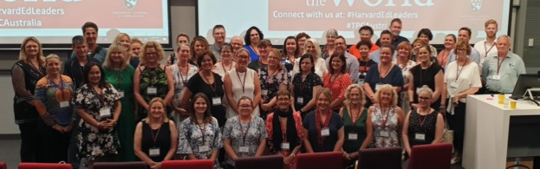

Harvard Club Scholarship winners at the inaugural Principals Centre in Australia

**Course pedagogy**

Four Harvard Graduate School of Education (GSE) faculty taught 171 Australian and New Zealand School Principals “*Leadership for School Excellence*”. The enrolment exceeded our target of 150 participants. Kay Merseth, Chair of Faculty, led her Professional team over four days through case studies and frameworks for planning using the best Harvard socratic method. She was supported by Matthew Miller, Liz City and Karen Mapp. Matthew taught frameworks for planning using the four windows frame, along with a case study of Lithgow High School especially developed for the centre. Liz taught strategy development, and tools for high performing teamwork. Karen led the Principals through an understanding of the critical importance of parent and community engagement. Kay provided the context and road map through the program and taught passionately about the importance of the instructional core to ensure student understanding and engagement with content being taught.

**Profile of participants**

The 171 participants represented all Australian states and territories, and New Zealand. They also represented all school systems including government schools, catholic schools and independent schools. The Department of Education in South Australia paid for places for 32 Principals and 2 system leaders through their ORBIS centre for professional development. The Department of Education in New South Wales paid for 30 places through their Professional Development Institute. We thank these two systems for playing a cornerstone role in this inaugural program.

Generous donors, largely, but not exclusively members of the Harvard Club of Australia, provided funding of $390,000 to support scholarships for Principals from Government Schools in disadvantaged communities, and regional and remote areas of Australia, and two Principals from less advantaged schools in New Zealand. Winners of the scholarships came from the Northern Territory, North Queensland, remote parts of WA as well as other states. This provided remarkable geographic diversity as well as diversity of school size and type. The scholarship winners were provided with a $4,000 contribution to the course fee, plus accommodation at St Pauls’ College Graduate House, and a travelling allowance to get to the program.

**Feedback from Participants**

Participants were overwhelmingly positive about the program, and its influence on assisting them to be more effective leaders of their schools. They reported that the curriculum was very relevant to their needs as leaders of schools, and that it provided them with tools and techniques to develop their skills as leaders. They expressed strong advocacy for the Program and their willingness to strongly encourage peer principals to attend future programs.

Participants were asked to complete an evaluation of the course. 128 (75%) responded including some statistical analysis and “verbatims”. The table below incorporates some, but not all of the statistical feedback:

|  |  |  |  |
| --- | --- | --- | --- |
| **Question** | **Maximum Score** | **Mean Score** | **Standard Deviation** |
| Program Objectives: |  |  |  |
| 1. Gain Deeper Understanding of Leadership Skills needed to set high expectations for Instructional Quality | 5 | 4.73 | 0.53 |
| 2. Become a more effective school leader | 5 | 4.73 | 0.5 |
| 3. Develop a leadership Strategy informed by data and learn how to align resources and initiatives around an evidence based approach | 5 | 4.42 | 0.77 |
| 4. Foster student achievement by increased engagement with families, community and school leaders | 5 | 4.73 | 0.54 |
| Overall Quality of the Program: | 5 | 4.88 | 0.35 |
| Relevance of the Program to your professional learning needs | 5 | 4.85 | 0.4 |
| Integration of the elements of your learning experience | 5 | 4.72 | 0.51 |
| Opportunities to engage with the community of learners | 5 | 4.78 | 0.5 |
| Value of the Program | 5 | 4.88 | 0.39 |
| Balance of Theory and Practice | 5 | 4.78 | 0.53 |
| How satisfied were you with the overall program? | 7 | 6.88 | 0.40 |

We consider this a remarkable result for a first-time program. There is feedback on certain aspects we can improve for the next program, including that it be run over five days, not four. A taste of some of the comments is:

“The most professionally inspiring and enriching professional learning I have participated in in 31 years in Education. The content was cohesive and presented in an intuitive way. The quality of the presenters as teachers and academics was second to none. Thank you for the opportunity. My school and staff I work with are already benefiting from the opportunity.”

“Participation in the *Leadership for School Excellence* course has strengthened my understanding of what is required to be a successful school leader. I have acquired a toolkit of evidence based strategies that I can utilise to lead school improvement and that will ultimately secure school excellence”.

“I would highly recommend this course to leaders as a way of raising the bar for the work

**GSE and HCAP roles**

The Graduate School of Education was responsible for the application and admissions process, marketing, course design, course content, cases, key account liaison and on site direction. Cate Gardner, was Program Director reporting to Stephen Hyde, Director of Professional Education at GSE. Cate was supported by Julia Pasquale in Sydney. The financial surplus of $US400,000 arising from the program was remitted to GSE.

HCA Philanthropy acted as Invoicing agent, so as to remit GST to the Australian Tax office. Total revenue from the Program amounted to over $750,000, which resulted in a net payment of GST after input credits of $64,000. Chris Smith MBA ’77 led the initiative and assembled a local sales and operations team to deliver a very high quality experience for the Principals. Our objective was to “put the Principals on a pedestal” in keeping with the concept expressed by David Gonski at the 2012 AGM of the Club.

Ricky Campbell-Allen EdM’10 energetically engaged with curriculum design and led the push for enrolments. Chris and Ricky were supported by club administrator Justina Blackman, Gabi Kelland as Program logistics manager, Ian Hill as Site operations manager. Melinda Muth MBA ’79 kept a watchful eye on proceedings sharing her considerable skill and experience of five years directing our Program for Leaders. She also assisted in successfully selling places into the Catholic School System.

HCAP arranged accommodation at St Pauls’ College Graduate House which was very favourably commented upon by participants, in keeping with our objective of giving the Principals a first class experience. Our thanks to Kate Bowery, General Manager of St Pauls’ College Events and Stays for managing the complexity of this inaugural Program.

**Donors and Charitable partners**

Donors were key to success providing funding to ensure economic viability. Donations needed to be channeled through Deductible Gift Recipient charitable partners. These partners also provided very valuable promotional support through their school contact networks.

16 donors contributed $390,000 to scholarship funding, including donations from several charitable foundations. To ensure compliance with Australian Taxation legislation these donations were channelled through Education Charities. The donors in order of size of donation were:

|  |
| --- |
| Eureka Benevolent Foundation |
| Winchester Investments |
| Michael Ahrens |
| Christopher Smith |
| Roger Massy-Greene |
| Harvard Club of Australia Philanthropy |
| Yarranabbe Foundation |
| Wesfarmers Limited |
| Vernon Foundation |
| Coles Supermarkets |
| David Friedlander |
| Bradley Foundation |
| Berg Family Foundation |
| Justin Punch |
| Steve Hawkins |
| Sophie Massy-Greene |

The Donations were channelled through a number of charitable partners.

|  |  |  |
| --- | --- | --- |
| Donation intermediary | $ | Comment |
| Australian Business and Community Network | 109,090 |  |
| Australian Schools Plus | 103,000 |  |
| Public Education Foundation | 83,500 |  |
| Roger Massy-Greene | 40,000 | Donated to Harvard Club of Australia Foundation for Future Principals Centre in Australia |
| Social Ventures Australia | 10,700 |  |
| Clontarf Foundation | 16,000 | Tuition fee subsidy for 4 Principals paid by Wesfarmers Limited. |
| Aurora Education Foundation | 12,000 | Tuition fee subsidy for 3 Principals funded by Harvard Club of Australia Philanthropy |
| Coles Supermarkets | 8,000 | Tuition fee subsidy for 2 Principals |
| Christopher Smith | 8,000 | Tuition fee subsidy 2 New Zealand Principals |
| Total Receipts | 390,290 |  |

Expenditure on the 53 Scholarships awarded amounted to $282,000, leaving a surplus of $108,000 to carry forward to the next Principals Program. $40,000 of these funds is held in HCA Foundation and the balance is held by HCA Philanthropy.

**The Future**

Our longer-term vision is to stage this program every year giving the opportunity to the 10,000 Principals in Australia and 2,500 in New Zealand. We also seek to have delegates from the Asia Pacific region to give participants the opportunity to learn from other school system leaders. Please engage with school principals that you know to spread the word.

The 2021 Principals Centre in Australia - Leadership for School Excellence is likely to be deferred to January 2022 as a result of the Corona Virus Public Health measures.

**Donations from Members**

Donations received during the year amounted to $445,000. Of this $351,000 was donated by members and their associated entities, which is a significant increase to $63,500 donated in the prior year. Members donated $2,777 at the time of renewing their memberships (prior year $3,993). This was forwarded to the Harvard Club of Australia Foundation. Thank you for considering a donation when you renew your membership.

Donors for the Principals Program were: Roger Massy-Greene MBA’79 $47,000 in recognition of his 40th reunion, and $68,750 from his associated Eureka Benevolent Foundation; $48,000 from Christopher Smith MBA‘77; John Roth MBA’76 and Jillian Segal LLM’83 contributed $25,000 through their Foundation; Michael Ahrens LLM’62 contributed another $20,000 for the Principals Program; Tony MBA’70 and Carol Berg, Graham LLM’73 and Charlene Bradley, and Justin Punch MBA’94 each contributed $5,000 to the Principals Program.

Donations from non members to the Principals Program included $50,000 from Winchester Investments, $20,000 from the Vernon Foundation, $16,000 from Wesfarmers Limited and $8,000 from Coles Supermarkets Limited.

Our Patron, Jim Wolfensohn donated $US30,000 to support the Wolfensohn Scholarship program, and Bill and Lea Ferris paid for 2 Non Profit Scholars to attend the Strategic Perspectives in Non-profit Management at Harvard Business School. Tony Berg contributed $10,000 to the R.G. Menzies Scholarship fund at ANU.

This is a magnificent effort and greatly appreciated by the club and the 67 Scholarship winners who are acknowledged in our honour rolls at the conclusion of this report.

Australian donors are able to claim a tax deduction for donations to the Harvard Club of Australia Foundation, managed by Perpetual Trustees, and also for donations to the R.G. Menzies Scholarship fund at the Australian National University. This later fund has a Deductible Gift Recipient item 1 approval, enabling ANU to accept donations from Private ancillary funds and foundations. HBS alumni in Australia get class and section recognition in the HBS Contributors report for donations made in Australia to HCAF and ANU. Importantly, this is the only way to make an Australian tax deductible donation for your HBS reunion gift. Alumni in the US can donate tax effectively to the R.G. Menzies Fund at Harvard University.

Please consider donating in support of our scholarship and professional development programs. When you are next updating your will, please consider a bequest.

**Earnings from Endowment Funds**

The Club scholarship programs benefit from three endowment funds: The R.G. Menzies Scholarship Fund at ANU, a smaller but similar fund for postgraduate study managed by Harvard in the US, and the Harvard Club of Australia Foundation – a Private Ancillary Fund. These endowment funds also provide the opportunity to maintain distributions for Scholarships in periods when there is no income from Programs, as will be the case in 2020.

The ANU endowment has $2.024 million in the R.G. Menzies general fund and $478,000 in the MBA specific fund*.* We aspire to build the MBA fund towards $1 million before awarding scholarships from this fund. Annual distributable earnings are about $70,000 (5.5%) in the general fund, and the capital value of the investment pool is growing at about 6%. There is a gap between the value of scholarships awarded each year (US$76,000) and donations received and income being generated. The Harvard Club of Australia has made donations to the R.G. Menzies fund to fill this gap until the capital sum grows to sustain two scholarships each year. These donations were $25,000 in 2018 and $30,000 in 2019. We have also discussed awarding 3 scholarships every two years as a way of living within our means. To date this has not been necessary.

The HCA Foundation has an endowment balance of $1,718,881 at June 30th 2019. Investment returns for the year to June 2019 were $81,175 income return (5.2% on average balance) and 5.9% capital growth. In the prior year to June 30th 2018 the Income received was $66,436 (4.9%) and capital growth 4.7%. HCA Philanthropy is Joint Trustee with Perpetual Trustees Limited and is represented by Christopher Smith MBA’77, Matt Loughnan GMP ‘16 and David Jones MBA ‘92. Donations distributed during 2019 amounted to $308,000 (Prior year $115,500). Donations received during 2019 amounted to $504,000 of which $396,000 was donations from HCA Philanthropy as a means of increasing the invested capital of HCA Foundation. (Prior year $46,000). Individual donors are acknowledged in the list of donors at the back of this report. Thank you donors!

The endowment at Harvard produces $US 44,000 annual contribution to the tuition fees for full time study by R.G. Menzies Scholars selected in Australia.

**Our Scholarships**

Giving Back through a range of scholarships has been a core purpose of the Club since 1968 when the Club initiated the R.G. Menzies Scholarship Program. The Australia Harvard Fellowship Program was initiated in 2004 to bring Harvard Researchers to Australia and live up to the original wish of Sir Robert Menzies that the scholarship in his name would foster two way exchange with Harvard.

In 2001 we added the non Profit Fellowship, and in more recent years the Public Education Foundation Principals Scholarship, the Wolfensohn Scholarships and an Indigenous Education Scholarship with the Roberta Sykes Indigenous Education Foundation.

Club members can apply for the Clive Gard Scholarship which gives a free seat at the annual Program for Leaders worth over $10,000. Members can also volunteer to join selection panels for each of our Scholarships or to take a turn at leading a Scholarship Program.

**2020 Harvard Club R.G. Menzies Scholarships**

The 2020 selection round for the RG Menzies scholarship has now concluded with another two outstanding Australians succeeding amongst a group of extremely talented candidates. Applications this year totaled forty-nine. This number was reviewed and reduced to a short list of sixteen, then a final group of six were invited for formal interviews in early April.

The R.G. Menzies Scholarship is the flagship scholarship program of The Harvard Club of Australia and now marks its 52nd year. Founded by Sir James Wolfensohn in 1968, the program has grown steadily in all respects and is recognized as one of the most prestigious post graduate scholarships in Australia, offering two scholarships at USD 60,000 each. Since inception, the Harvard Club of Australia has supported ninety young men and women with scholarship funding to Harvard. Candidates are reviewed around the overarching objective of their potential to make a significant contribution to Australia and in this context, are then considered under the headings of leadership, intellectual ability and breadth of vision.

The scholarship selection process is carried out jointly with the Australian National University and we each provide three selectors. A seventh selector has historically been included representing the Menzies Foundation, so long as they provide financial support for the program.

Jon Chambers is our R.G. Menzies Program Leader and continues his role as a selector. Additional HCA selectors contributing for their second year include Dr Nayana Vootakuru, (a Menzies scholar - 2010), and David Niall who was invited to represent the Harvard Club of Victoria. From the ANU, Chair of the selection committee was Dr Suiwah Leung (Crawford School of Government). Professor Glen Withers (Research School of Economics – and a Menzies Scholar – 1970) and Professor David Hambly (ANU College of Law)

This year the Covid-19 shut down prevented the normal flow of activities and presented some logistical challenges which were well managed by the ANU. We thank Suiwah Leung and Lindsay Burrows (ANU scholarship administration) for their efforts in these circumstances. In place of the normal face to face interviews of all finalists held at the ANU campus in Canberra, this year the interviews were done via ZOOM. After some “familiarisation” - the process went very well.

This year’s winners are Christopher Wong and June Ma. You will see from reading their profiles that they are worthy recipients of our scholarship by meeting the requirements of leadership, intellectual ability and breadth of vision and consequently have the capacity to be significant contributors to Australia.

**Dr CHRISTOPHER X WONG**

Chris is an academic and clinical cardiologist specialising in cardiovascular medicine and heart rhythm disorders. He has been accepted to attend the TH Chan School of Public Health where he will complete his Master of Public Health with a focus on complex epidemiology and data analytical approaches.

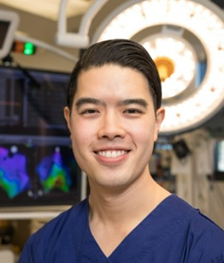

Chris has a record of outstanding academic and professional achievement. He graduated from the University of Adelaide with a Bachelor of Medicine and Surgery. He went on to be a Rhodes Scholar and completed Masters in Science degrees in Clinical Trials and Global Health at the University of Oxford, at Distinction level. He has also completed his PhD at the University of Adelaide, with Dean’s Commendation, in cardiovascular medicine.

Chris aspires to head a world leading unit committed to excellence in cardiovascular care, cutting-edge research, and educating the next generation. As a physician-scientist with an equal emphasis on both clinical medicine and scientific research, he believes he is well placed to identify the crucial questions facing patients and conduct studies that can practically change medical practice.

His intention is to achieve this through an active university research group and a commitment to practical and efficient health care delivery via involvement in professional organisations and public service.

In addition to his professional activities, Chris has had extensive extra-curricular interests. He is a past President of the Adelaide Medical Students Association, a past National Vice-President of the Australian Medical Students Association,and was elected to serve as one of the three student representatives on the Adelaide University Council. He also has an interest in music, having been a member of the Australian Doctors Orchestra, and has run in both the Adelaide and London marathons.

**Ms JUNE MA**

June is an economist at the Reserve Bank of Australia (RBA) and will be undertaking a PhD in Economics at Harvard in the Graduate School of Arts and Sciences.

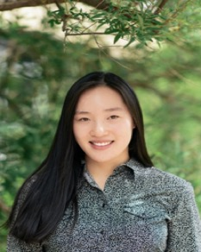

June has an enduring interest in how people make decisions in the context of policy and regulation. Her curiosity led her to pursue a combined Economics/Law degree where she graduated with first class honours in both disciplines.

During her undergraduate studies, June’s enthusiasm for Economics grew as she formed the view that it is the basis of all good policy, and determined that a career as an economist would be the best use of her skills to contribute to Australia.

For her honours thesis, June studied the economics of Bitcoin. June’s paper was the first to provide an economic model of Bitcoin mining and its underlying technology which underpins the verification and processing of transactions on any proof-of-work based blockchain and she has been widely recognized for her expertise in this area.

June joined the RBA after graduation where she has worked on both monetary policy and payments policy issues. She has leveraged her expertise to make a significant contribution to the RBA’s research on cryptocurrencies and worked on experiments for a central bank digital currency. June has also researched the impact of macroeconomic developments and structural changes in China and India on the Australian economy, which was used by the Board in determining monetary policy decisions.

Outside of her studies, June has also excelled in sports. Through her high school years, she was actively involved in basketball, tennis, rowing, and swimming. She represented the ACT in basketball at national competitions and was awarded the Pierre de Coubertin Award by the Australian Olympic Committee in recognition of her sporting achievements and commitment to the Olympic values.

After she completes her PhD, June intends to focus her research on policy issues relevant to Australia and contribute to public debate. Following her period in academia, she intends to return to the RBA in a role that has a more direct impact on policy formulation affecting all Australians.

**2019 Australia- Harvard Fellowships**

The Australia Harvard Fellowships were established in 2004 under the leadership of John Turner AMP’86, with the aim of encouraging knowledge exchange between Harvard University and Australian Universities and Research Institutes. This intent is consistent with the origins of our R.G. Menzies scholarship program which envisaged Harvard academics visiting Australia, as well as offering post graduate study at Harvard. This program has been chaired by Professor Mathew Vadas AO MBBS’70 of the Centenary Institute, and Dr. Galina Kaseko GMP’12 of the Stephen Sanig Research Institute, as Program Leader. Prof. Bob Graham AO is taking on the role of Chair of selectors from 2020 onwards. Since Inception $1,228,000 has been awarded to 74 Fellowship recipients. This program is highly regarded in life science research circles and has resulted in several substantial National Health and Medical Research Grants, and two Professors migrating to Australia for lengthy periods of research at Australian Medical Research Institutes, and acknowledgement of Hala Zreiqat as Woman of the year in NSW in 2018.

The 2019 selection panel, comprising Professor Mathew Vadas AO MBBS’70, Professor Bob Graham AO (Associate Professor of Medicine ’82-’87), Dr. Sue Morey AM MPH’80, Alice Killen MPH’87, supported by Dr. Galina Kaseko GMP’12, met in early December 2019 and selected four new Fellows with an investment of $49,500.

HCA Foundation is proud to recognise four outstanding researchers to become the 2020 Australia-Harvard Fellows. Recipients will be contributing to the advancement of scientific knowledge and research in Australia, and to the enhancement of links between Harvard University and Australian academic institutions.

Professor Vadas is retiring as Chairman of selectors. We thank Professor Vadas for his role as Chairman of selectors over five years. We also acknowledge Helen Warwick, Professor Vadas’s Executive Assistant who has supported the scholarship selection process over five years, and manages disbursements to host Universities and Institutions. Helen is planning to continue her role supporting the Fellowships.

The four 2020 Fellows are:

**Professor Karol Miller** UWA Head of Department, Director of Intelligent Systems for Medicine Laboratory University of Western Australia, who will visit Prof. Ron Kikinis, M.D. Professor of Radiology, Surgical Planning Laboratory, Brigham and Women’s Hospital in Boston; Robert Greenes Distinguished Director of Biomedical Informatics and Simon K Warfield, Thorne Griscom Chair of Radiology, Director of the Computational Radiology Laboratory and Director of Research in the Department of Radiology at Boston Children,s Hospital.

**Associate Professor Yu Shrike Zhang** Assistant Professor; Associate Bioengineer; Director,Laboratory of Engineered Living Systems and Harvard Medical School and Brigham and Women’s Hospital who is visiting Prof. Anthony S Weiss, McCaughey Chair in Biochemistry and Professor of Biochemistry and Molecular Biotechnology; Leader, Charles Perkins Centre node in Tissue Engineering and Regenerative Medicine, Life and Environmental Biosciences at Sydney University.

**Associate Professor Yang (Ted) Teng** Director Lab of SCI, Stem Cell and Neurobiology research Harvard Medical School and Spalding Rehab Hospital Network who is visiting David Lloyd Professor, School of Allied Health Sciences, Griffith University. Chair Gold Coast Centre for Orthopaedics Research, Engineering and Education (GCORE) and the Menzies Health Institute.

**Joyce Bishoff** PhD Professor of Surgery, Vascular Biology Program at the Department of Surgery, Children’s Hospital Boston and Harvard Medical School, who is visiting Dr. Mathias Francois The David Richmond Transcriptional Regulation & Gene Editing in Cardiovascular Development at the Centenary Institute of Cancer Medicine and Cell Biology.

**2019 Non-Profit Fellowships**

The Non-Profit Fellowships were established in 2001 to bring enhanced leadership skills to the Australian non-profit sector; enable leaders to examine their mission, develop new strategies and improve the effectiveness of their organisation; and benefit the Australian community generally.

The Non-Profit Fellowships are funded by Bill and Lea Ferris. They enable two Fellows selected from the non-profit sector Australia-wide to attend the renowned Harvard Business School course titled [“Strategic Perspectives in Non-profit Management” (SPNM)](http://www.exed.hbs.edu/programs/spnm/) which is held each year in July.

Nominees must be the head of a non-profit organisation who has the potential to have a significant impact in the non-profit sector, and who meets various additional criteria.

Applicants may be nominated by an HCA member, a past Non-Profit Fellow or the Chairman of their organisation. Applicants may also self-nominate but must nominate a referee.

The Program Leader is Past President Lisa George, who has recently transferred to Singapore, but plans to maintain her role.We thank Lisa and her selection panel, Anita Kumar, Tony Massaro, Patrick Regan, and Ben Sebel who selected the winners. The Australian Scholarships Foundation assisted in the administration of applications.

The awards were presented at the annual Non-Profit Lunch on May 27th, 2019, hosted by Macquarie Bank, and presented by Sam Meers AO, founding director of the Nelson Meers Foundation.

The 2019 winners were;

**Karen Crouch**, Chief Executive Officer, Anglicare Southern Queensland

Anglicare Southern Queensland is one of the oldest & largest providers of social services in the state, including disability and aged care, foster & kinship care, mental health counselling & intervention services, and finally crisis & transitional housing to women & children at risk of homelessness.

The organisation is in the midst of large changes due to the introduction of the National Disability Insurance Scheme and the Royal Commission into Aged Care. Karen seeks to review the strategic direction of the organisation in light of these changes on the horizon and respond effectively. Specifically, she is keen to transform the organisation to be more ‘customer-centric’, establish partnerships and create a high-performing organisation.

We saw several applications from this sector, and Karen’s application and interview demonstrated a great willingness to embrace the change for the benefit of their clients.

Karen began her career as a Registered Nurse and has been with the organisation for over 10 years. She has been CEO for 6 years.

**Matt Davis**, National Director, Salvos Stores

The Salvos Stores is the wholly owned social enterprise subsidiary of the Salvation Army. Its unique contribution to the mission of the Salvos is to provide communities with retail experiences that enable social and environmental impact. The national network of 330 retail sites generates much-needed support for Salvation Army programs by serving over 200,000 customers per week, employing 12,000 staff and volunteers and recycling over 30,000 tonnes of donations from the community that might otherwise have been destined for landfill.

Matt presented quite a unique challenge to take to Harvard- one related to waste reduction & ‘textile sustainability’ associated with the wares in their stores and the current ‘fast fashion’ movement. He seeks some new strategic perspectives on these issues, not just from Harvard but also some other organisations he’s identified to visit in the US that do this well.

Matt has been in this role for 3 years and also Chairs the industry body here in Australia so will seek to share these learnings more broadly.

No award will be made in 2020 as a consequence of the Covid 19 pandemic.

**2019 Sir James Wolfensohn Public Service Scholarships**

The Sir James Wolfensohn Public Service scholarship was established in 2012 with the financial support of the former chairman of the World Bank; Patron and Past President of the Harvard Club of Australia, Sir James Wolfensohn. It was established to promote the development and delivery of good public policy. There have been 25 scholars to date including those selected for 2019/20. Each of the candidates has been chosen on the basis of their potential to contribute to the benefit of Australian society. Many of the previous scholars have advanced in their careers to senior roles in State and Federal government.

The 2019/20 recipients of the Sir James Wolfensohn Public Service Scholarship are;

· **Anne Skewes**, Deputy Secretary, Land and Housing Corporation, NSW Department of Family and Community Services

· **Elizabeth Heffren-Webb**, Deputy Secretary, Commonwealth Department of Social Services

· **Jason Ardler,** Deputy Secretary and Head of Aboriginal Affairs NSW

· **Meredith Day Huntingford**, Department of the Attorney General and Justice, Northern Territory

The scholarships will allow these four executives to undertake executive education programs at Harvard University’s John F. Kennedy School of Government in 2020.

The four recipients were chosen from a wide field of candidates, all nominated by a Commonwealth, state or territory department or agency head. A shortlist of candidates was interviewed by a panel of Harvard University alumni comprising Luke Woodward (Gilbert + Tobin) Naomi Flutter (Westfarmers), Nick Whitlam (Port Authority of NSW) and Peter Thompson (the Australia and New Zealand School of Government). Bella Vincent, Matt Cross, Kimberly Everett and Elizabeth Carr supported the selection panel by reviewing the applications, and shortlisting candidates for interview.

Luke Woodward hosted a celebratory lunch for the Wolfensohn Scholarships in November 2019. This lunch, funded by Gilbert+Tobin, was attended by 55 Club Members and Guests including 10 Scholarship winners. The guest speaker was Martin Parkinson, recently retired Secretary of the Department of Prime Minister and Cabinet, who spoke on the breadth of policy, institutional and associated challenges the public sector will confront in the years ahead. He also shared some key lessons in leadership that had guided his approach over his career. Sir James Wolfensohn was interviewed by Naomi Flutter in New York, and the video of this interview was played at the Lunch. Sir James reflected on his career, including his association with the Harvard Club, and the importance of good public sector leadership and policy.

The 2018/19 recipients of the Sir James Wolfensohn Public Service Scholarship were;

**Richard Bolt,** Secretary, Department of Economic Development, Jobs, Transports and Resources in Victoria,

**Rebecca McGarrity**, Executive Director Social Policy, Queensland Department of Premier and Cabinet,

**Damon Rees**, CEO, Service NSW and

**Darren Foster**, Director General, WA Department of Premier and Cabinet

**2020 HCA Education Scholarships**

David Gonski, the guest speaker at our 2012 AGM, challenged us to “put principals on a pedestal”. As a consequence of this challenge, former HCA President, Patrick Regan EdM’06, initiated this transformative scholarship program to send outstanding public school principals from around Australia to the Harvard School of Education to undertake a week long professional leadership development program.

The Public Education Foundation, and Teachers Mutual Bank along with our support, has subsequently enabled 23 Australian public school principals to attend these professional development courses at the Harvard Graduate School of Education.

These Scholarships have developed a high profile in the education sector. The Principals Program taught at Harvard has a high level of participation by Australian principals which has encouraged Harvard GSE to offer their first course outside the USA.

Since 2016, our involvement in the HCA Education Scholarship has been managed by Ricky Campbell-Allen EDM’10. Scholarships are awarded to early to mid-career principals who demonstrate significant leadership impact in their school and a commitment to public education.

The 2020 Public Education Foundation Scholarships to Harvard were won by;

* **Tracey Breese** - Kurri Kurri High (NSW, rural) Teachers Mutual Bank Principal’s Scholarship
* **Michael Hornby** - Mable Park State High School (QLD, metro) Harvard Club of Australia Principal’s Scholarship
* **Paula Hambly** - Batemans Bay High School (NSW, rural) Public Education Foundation Principal’s Scholarship

The 2019 Public Education Foundation Scholarships to Harvard were won by;

* **Karen Duncan**, Harrisdale Primary School (WA) - Teachers Mutual Bank Principals Scholarship
* **Ann Caro**, Lithgow High School - Harvard Club of Australia Principals Scholarship Recipient
* **Jesmond Zammit**, Gorokan Primary School - Public Education Foundation Principals Scholarship Recipient

Each Principals Scholarship is valued at approximately $16,000 and includes program tuition for one of two prestigious Harvard Graduate School of Education programs: Improving Schools: The Art of Leadership or Leadership: An Evolving Vision.

**Supporting Indigenous Education**

We have changed the focus of our Indigenous scholarship to support the Principals Centre in Australia. This is in recognition of the pivotal role played by Principals in transforming the lives of students and their communities. Roberta Sykes Indigenous Education Foundation, managed by Aurora, has until now focussed on overseas postgraduate study opportunities for indigenous Australians. The small pool of indigenous students qualified for overseas study opportunities has caused Aurora to work on the need to improve the aspiration of indigenous students all the way from primary school, through high school, into university and subsequently into post- graduate study.

In 2019 HCA Foundation donated $15,000 to the Aurora Indigenous Education Foundation and $10,000 to the Roberta Sykes Indigenous Education Foundation in 2019. The Chair of RSIEF is Peter Waters LLM’87 who is providing the leadership to change the focus of our support towards the Principals Centre in Australia. The funding provided to Aurora in 2019 supported 3 Principals from Public Schools with a high proportion of Indigenous students. The winners were:

**Everal Eaton** - Southern River College - Perth WA

**Carol Daniels** - Armadale State High School - Perth WA

**Kylie Cattaway** - Newton Moore State High School - Bunbury WA

We have subsequently donated $25,000 to Aurora for future Principals Programs to support scholarships to Indigenous Principals and Principals in secondary schools with significant indigenous enrolment.

In 2019 we supported a school Principal identified by Aurora to attend the Principals Program at Harvard with an investment of $15,000. The winner of this scholarship was Everal Eaton, Principal of Southern River College in WA who attended the Principals program at the Harvard Graduate School of Education in 2019.

Until 2019 we have supported postgraduate study by indigenous Australians at Harvard, and short course leadership programs to Indigenous community leaders.

The Harvard Club has a long history of supporting Indigenous scholars including Noel “Bilyana” Blomeley, a 1992 R.G. Menzies Scholar who completed an EdM at Harvard, Selwyn Button a 2017 Wolfensohn scholar is now Registrar of Aboriginal and Torres Strait Islander Corporations. This year Jason Ardler, deputy Secretary, and Head of Aboriginal Affairs in the NSW Government is one of the Wolfensohn Scholars.

**Clive Gard Scholarship**

The Clive Gard Scholarship is named in honour of our long time Club Administrator who was instrumental in successfully operating our Program for Leaders until 2014, contributing several million dollars to the endowment funds for our scholarship programs. The scholarship is available to club members, in mid-career, to attend the HCA Program for Leaders. The winner is selected by the Club President and executive in June each year. 10 members have benefited from this scholarship, and others have been offered a discounted place.

The 2019 winner was Andrew Hahn who completed his Advanced Management Development Program at the Harvard Graduate School of Design in 2018. The 2018 winner was Sarah Tesar, MPP’16 who has been active in organising events for Young Members.

This scholarship is a valuable benefit of membership and is a strong reason to maintain your membership of HCA.

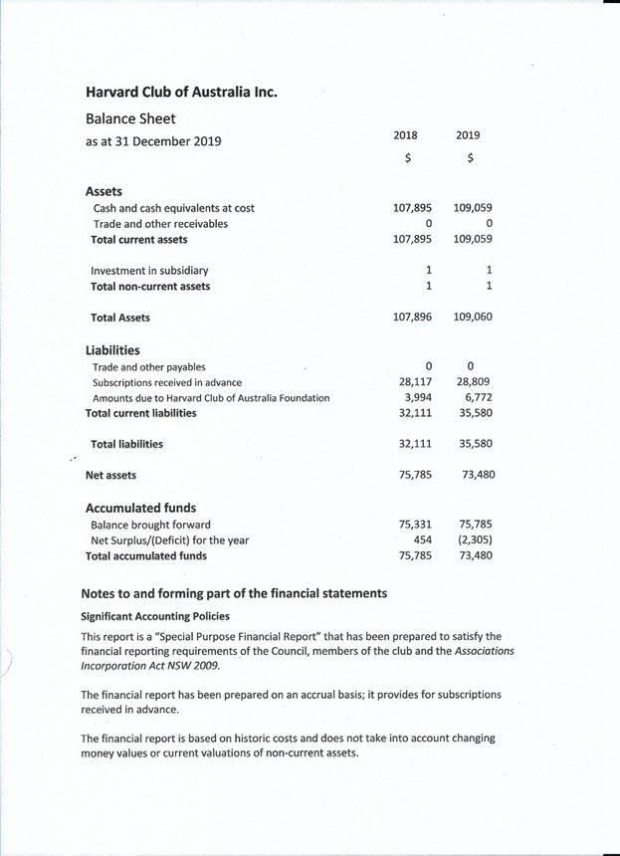

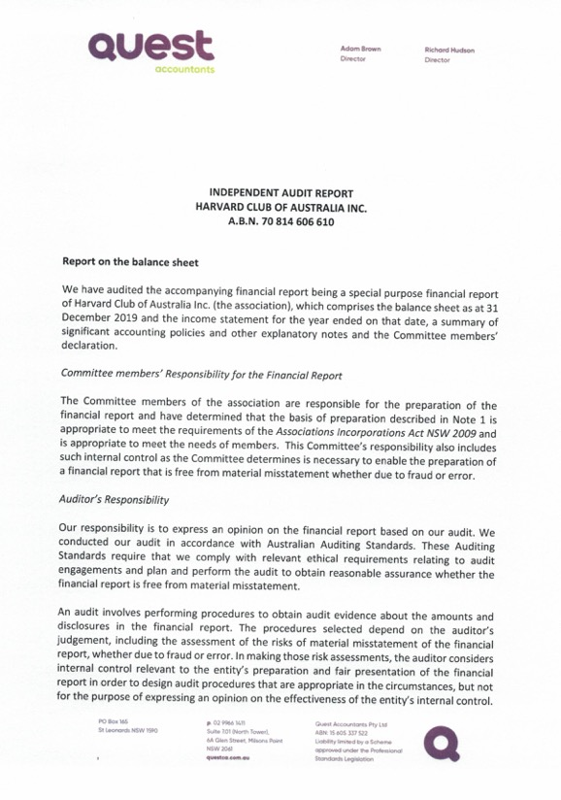

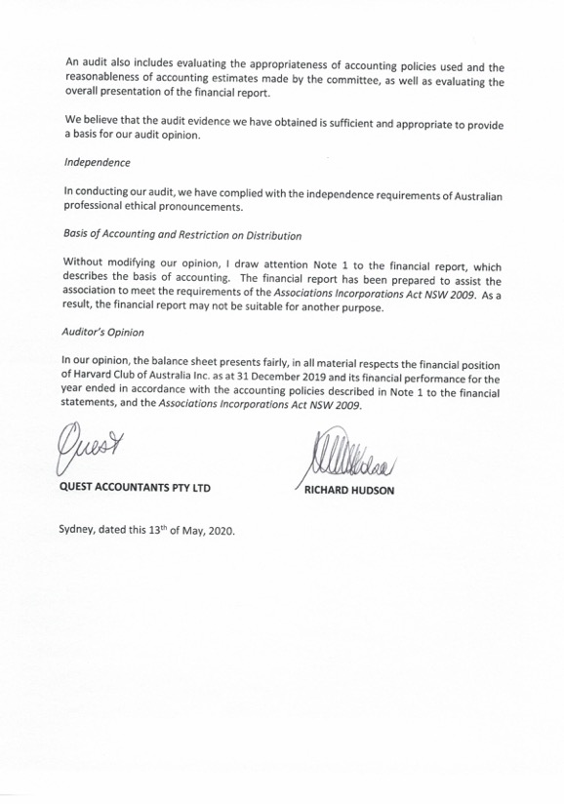

**Formal Directors Report HCA Philanthropy Pty Limited**

The Directors of HCA Philanthropy Pty Limited herewith submit the annual financial report for the financial year ended 31st December 2019.

**Principal Activities**

The principal activity of the company in the course of the financial year was to operate Executive Leadership Programs taught by Harvard professors with the objectives of bringing Harvard quality leadership development to Australia, promoting the Harvard Brand in Australia and to make a profit to benefit Scholarship and Fellowship programs of the Harvard Club of Australia. HCA Philanthropy is also a joint corporate trustee for the Harvard Club of Australia Foundation along with Perpetual Trustees Limited.

**Review of Operations**

The 2019 Program for Leaders and Non Profit workshop produced a profit contribution of $247,703 ($214,301 in 2018). The company reported a deficit of $211,963 in 2019 as a result of making donations to HCA Foundation ($396,000) and the R.G. Menzies Scholarship Fund at ANU ($55,000). Expenditure for Wolfensohn scholars attending programs at Harvard Kennedy School of Government ($36,767) was offset by a donation of $40,988 received for the Wolfensohn scholarships.

The company held US dollar balances at balance date to meet liabilities for the Principals Centre in Australia held in January 2020, and for future US dollar expenditure on professor fees and scholarships. An adverse foreign exchange valuation adjustment of $10,469 was reported as a result of year end exchange rates on these US dollar balances being higher than the cost of these funds.

**Changes in state of affairs**

The company sponsored the establishment of a professional development program for school principals during the year. This program was successfully held between January 11th and 15th 2020.

**Subsequent events**

HCA Philanthropy P/L invoiced tuition fees for the Principals Centre in Australia and collected GST on this revenue for remittance to the Australian tax office. US$450,000 has been remitted to Harvard Graduate School of Education in accordance with our agreement with them.

The Covid 19 pandemic since the end of the financial year has required deferral of the 2020 Program for Leaders and Non Profit workshop until July 2021. An operating loss of about $50,000 will be reported in 2020 as a result of marketing and administrative expenses not able to be recovered. Accommodation deposits for these programs will be honoured by the provider for the 2021 program.

**Directors and Remuneration**

Christopher Smith MBA‘77 (Chairman)

Melinda Muth MBA’81 (Secretary and Director)

Charles Graham MBA‘01

Jon Chambers OPM’91

Kimberly Everett MUP’98

Justin Greiner MBA’00

Matthew Loughnan, GMP ‘16

With the exception of Melinda Muth, the directors are not remunerated. Melinda Muth’s service company received a fee of $35,000 for operating the 2019 Program for Leaders. (2018 $ 37,000)

**Attendance at Board meetings**

The directors held 4 meetings during the year, including two by circular resolution:

|  |  |  |
| --- | --- | --- |
|  | **Meetings eligible to attend** | **Attended** |
| **Chris Smith** | **4** | **4** |
| **Melinda Muth** | **4** | **3** |
| **Charles Graham** | **4** | **3** |
| **Jon Chambers** | **4** | **4** |
| **Mathew Loughnan** | **4** | **3** |
| **Justin Grenier** | **4** | **0** |
| **Kimberly Everett** | **4** | **2** |

**Parent entity**

Financial statements for HCA Philanthropy Pty Limited are provided in this annual report.

**Auditor**

Quest CA were appointed as auditors in December 2012. They continue in office as auditor.

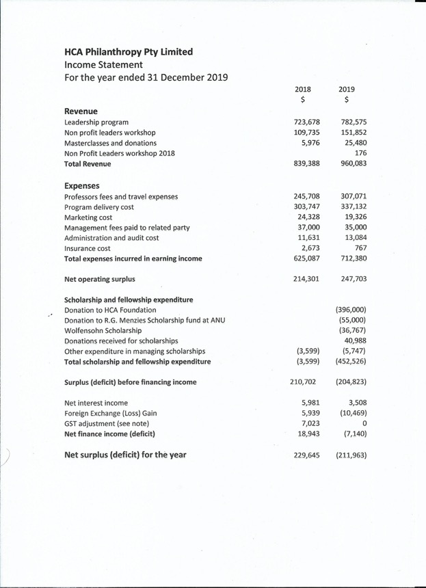

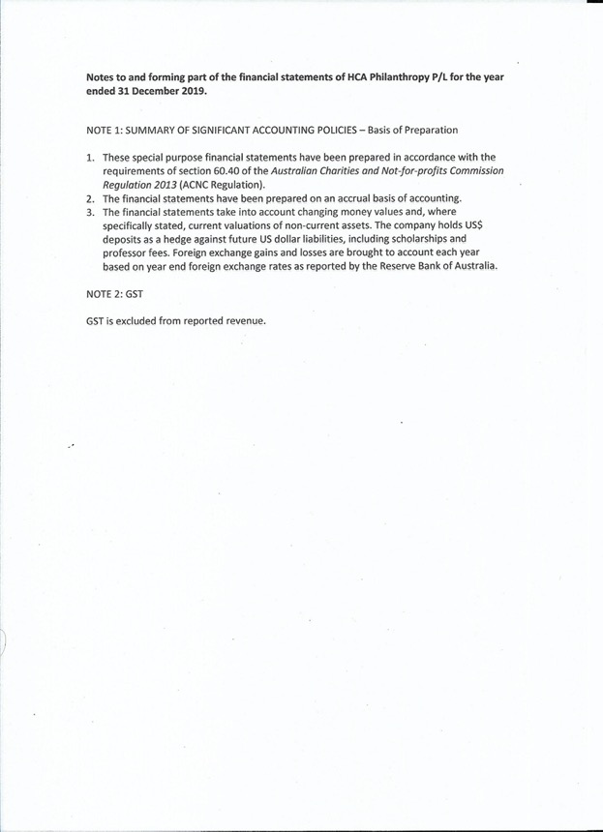

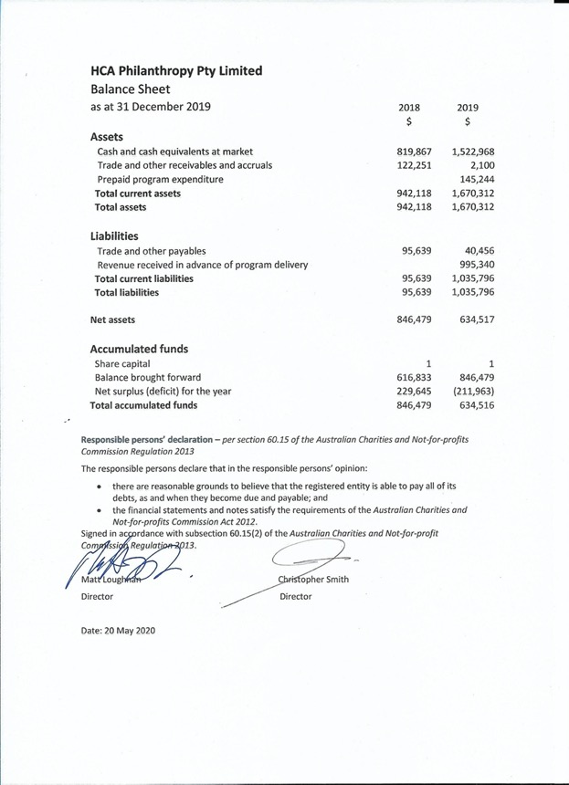

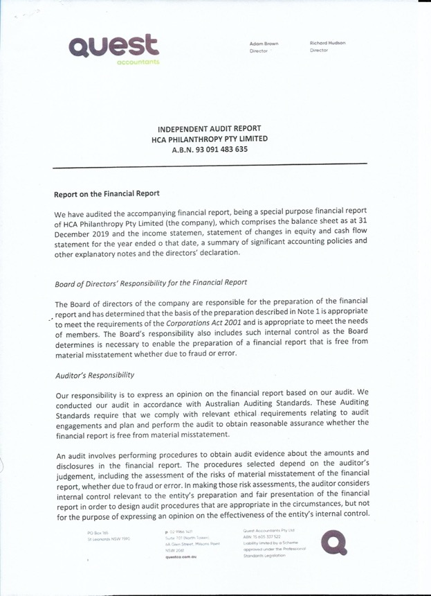

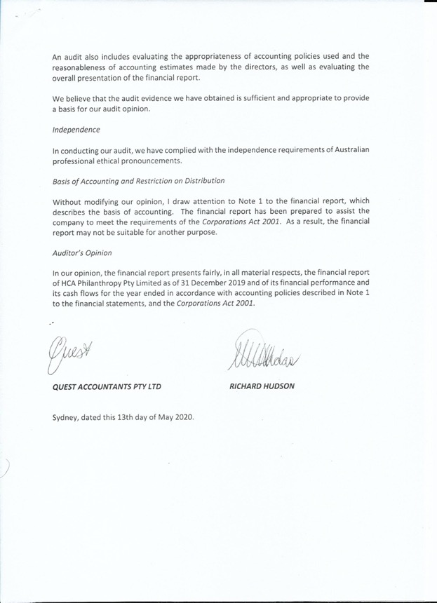

**HCA Honour Roll**

**Honour Roll of Presidents**

|  |  |
| --- | --- |
| **Tenure** | **Name** |
| 2018-present | Mr Charles Graham MBA’01 |
| 2016-2018 | Mr Justin Greiner MBA’00 |
| 2014-2016 | Ms Naomi Flutter MPP'98 & Ms Lisa George MPP’06 |
| 2012-2014 | Mr Patrick Regan EdM’06 |
| 2010-2011 | Mr Peter Hasko PMD’93 |
| 2008-2009 | Ms Joanna White MBA’98 |
| 2006-2007 | Mr Sam Weiss AB'76 |
| 2004-2005 | Mr Ross Love MPA’88 |
| 2002-2003 | Dr Melinda Muth MBA’81 |
| 2000-2001 | Mr Philip Stern MBA’82 |
| 1998-1999 | Mr David Pumphrey MBA’70 |
| 1996-1997 | Mr Christopher Smith MBA’77 |
| 1994-1995 | Mr Michael Quinn MBA’76 |
| 1992-1993 | Mr Graham Bradley LLM’73 |
| 1990-1991 | Mr Richard Kaan AM’65 |
| 1989 | Mr Rodney Lester MBA’79 |
| 1987-1988 | Ms Patricia Angly AB’69 |
| 1985-1986 | Mr John C Conde MBA’74 |
| 1983-1984 | Mr John K Doherty PMD’72 |
| 1981-1982 | Mr John Armstrong MBA’59 |
| 1979-1980 | Mr Ezekiel Solomon LLM’60 |
| 1977-1978 | Mr David S Clarke MBA’66 |
| 1974-1976 | Mr Theodore Simos LLM’59 |
| 1972-1973 | Mr Harry Seidler MAR’46 |
| 1970-1971 | Mr H. Anthony York MBA’64 |
| 1968-1969 | Mr Brooks C Wilson MBA’59 |
| 1966-1967 | Mr James D Wolfensohn MBA’59 |
| 1965 | Mr William A Lockley, AMP’63 |
| 1961-1964 | Professor Julius Stone, SJD’32 |

# **Honour Roll of Donors (donating >A$1000)**

|  |  |
| --- | --- |
| **Year** | **Name** |
| 2019 | Oliver Bladek MBA’10 |
| 2019 | Michael Ahrens LLM ‘62 |
| 2019 | Roger Massy-Greene MBA’79 |
| 2019 | Christopher Smith MBA ‘77 |
| 2019 | Berg Family Foundation |
| 2019 | Bradley Family Foundation |
| 2019 | Yarranabee Foundation |
| 2019 | Justin Punch MBA’ 94 |
| 2018 | Berg Family Foundation |
| 2018 | Jessica Roth* LLM’13 |
| 2018 | Errol Katz* MPP’98 |
| 2018 | Michael Ahrens LLM’62 |

*denotes Menzies Scholars

**The Menzies Scholars and Awards**

|  |  |  |  |
| --- | --- | --- | --- |
| **Year** | **Name(s)** | **School** | **Degree** |
| 2020 | Dr Christopher Wong | Public Health | MPH |
| 2020 | June Ma | Economics | PhD |
| 2019 | Alistair Quinn | Public Health | MPH |
| 2019 | Brigid McManus | Law | LLM |
| 2018 | Scott Bolton | Education | EdM |
| 2018 | Simon Dickson | Government | MPP |
| 2017 | Claire Rochecouste | Government | MPP |
| 2017 | Ellen Chapple | Law | LLM |
| 2016 | Sibella Matthews | Government | MPP |
| 2016 | Nick Gattas | Business | MBA |
| 2015 | Patrick Mayoh | Government | MPP |
| 2015 | Andrew Thomas | Business | MBA |
| 2015 | Matthew Tyler | Government | MPP |
| 2014 | Amy Chandran | Government | MPP |
| 2014 | Simon Malian | Science | MSc |
| 2014 | Angela Winkle | Business | MBA |
| 2013 | Christopher Tran | Law | LLM |
| 2013 | David Boyd | Education | MEd |
| 2012 | Jessica Roth | Law | LLM |
| 2012 | Tristan Webster | Business | MBA |
| 2012 | Matthew Brown | Business | MBA |
| 2011 | Julia Smith | Education | MED |
| 2011 | Luke Raffin | JFK | MPA |
| 2011 | Angela Lopes | HBS | MBA |
| 2010 | Gregory Keane | Public Health  Public Health | MPH |
| 2010 | Lakshmi Vootakuru | MPH |
| 2009 | Dr Stephanie Ward | Public Health | MPH |
| 2009 | Ricky Campbell-Allen | Education | MEdu |
| 2008 | Clare Barnett | Public Health | MPH |
| 2008 | Maja Cassidy | Eng & Appl Sc | APD |
| 2007 | Rosie Dawkins | Public Health | MPH |
| 2007 | David Clarke * | JFK | MPA |
| 2007 | Adam Palmer * | GSAS | PhD |
| 2006 | Tracy Slatyer | GSAS | PhD |
| 2006 | Joanna Davidson | Law | LLM |
| 2006 | Scott Griffin | HBS | MBA |
| 2005 | Katie Maree Connolly | Government | MPP |
| 2004 | Michael Murphy | Business | MBA |
| 2003 | Belinda Baker | Law | LLM |
| 2003 | Dan Siskind | Public Health | MPH |
| 2002 | Alexandra West | Government | MPA |
| 2001 | Nicholas Vines | GSAS | PhD |
| 2000 | Quang Nguyen | Business | MBA |
| 1999 | Jonathan Liew | Gov Business | MPA MBA |
| 1998 | Jonathon Redwood | Law | LLM |
| 1997 | Monica Nolan | Public Health | MPH |
| 1997 | Sarah Vickers-Willis | Business | MBA |
| 1997 | Justin Wolfers | GSAS | PhD |
| 1996 | Sophie Gee | GSAS | PhD |
| 1996 | Errol Katz | Government | MPP |
| 1996 | Luan Low | Law | PhD |
| 1996 | Peter Thomas | Business | MBA |
| 1995 | Fleur Johns | Law | LLM |
| 1994 | Anna Donald | Government | MPA |
| 1994 | Alister Iles | Law | LLM |
| 1993 | Esther Charlesworth | Design | MAR |
| 1993 | Fiona Percy | Public Health | MPH |
| 1992 | Heather Luntz | Law | LLM |
| 1992 | Felicity Scott | Design | MAR |
| 1992 | Noel Blomeley | Education | MEd |
| 1991 | Kim Rubenstein | Law | LLM |
| 1991 | Richard Bergin | Business | MBA |
| 1990 | Anne Pender | Education | MEd |
| 1990 | Michael Hiscox | Government | PhD |
| 1989 | Mark Kestin | Public Health | MPH |
| 1989 | Graham Eliott | GSAS | PhD |
| 1988 | Kimberley Elkins | Education | PhD |
| 1987 | David Srimgeour | Public Health | MPH |
| 1987 | Simon Grant | GSAS | PhD |
| 1986 | Merilyn Alt | Government | MPA |
| 1985 | Patrick Carroll | Public Health | MPH |
| 1984 | Julian McCarthy | Business | MBA |
| 1983 | Andrew Byrnes | Law | LLM |
| 1982 | Hilary Charlesworth | Law | LLM |
| 1982 | John Carlin | GSAS | PhD |
| 1982 | Adrian Jones | GSAS | PhD |
| 1981 | Ian Davidson | Law | LLM |
| 1980 | Helen Nugent | Business | MBA |
| 1979 | Henry Rigney | Law | LLM |
| 1978 | Peter Frost | Education | EdD |
| 1977 | Peter Parsons | Law | LLM |
| 1976 | George Kuczera | GSAS | PhD |
| 1976 | P G Marshall | Business | MBA |
| 1975 | Graham McDonald | Design | MAR |
| 1974 | Christopher Bain | Public Health | MPH |
| 1972 | Christopher Beale | Business | MBA |
| 1971 | Terrey Arcus | Business | MBA |
| 1970 | Glenn Withers | GSAS | PhD |
| 1969 | Anatolij Cork | Law | LLM |
| 1968 | Lionel Glendenning | Design | MAR |

# 

# **Australian Harvard Fellowships**

|  |  |  |  |
| --- | --- | --- | --- |
| **Year** | **Name(s)** | **School** | **Host** |
| 2019 | Karol Miller | University of Western Australia | Ron Kikinis M.D. Brigham and Women’s Hospital, Boston |
| 2019 | Yu Shrike Zhang | Harvard Medical School | University of Sydney (Charles Perkins Centre) |
| 2019 | Yang (Ted) Teng | Harvard Medical School | Menzies Health Institute, Griffith University |
| 2019 | Joyce Bishoff Ph.D | Harvard Medical School | Centenary Institute |
| 2018 | Professor Thomas Bortfeld | Harvard Medical School | The University of Western Australia, The University of Sydney, and The University of Wollongong |
| 2018 | Professor Bruce E. Landon | Harvard Medical School | The Menzies Centre for Health Policy |
| 2018 | Vikram Khurana | Harvard Medical School | The Garvin Institute |
| 2018 | Rachael Coakley | Harvard Medical School | The Robinson Research Institute and the Women’s and Children’s Health Network in South Australia |
| 2018 | Jonathan R.Polimeni | Harvard Medical School | University of Queensland |
| 2018 | Prof. Philip Hogg |  |  |
| 2017 | David Haig PhD | Harvard FAS | Sydney University |
| 2017 | Noel Michele Holbrook PhD | Harvard FAS | University Of Tasmania |
| 2017 | Zdenka Kuncic PhD | Sydney University | Harvard Medical School |
| 2017 | Sean W Cain PhD | Monash University | Harvard Medical School |
| 2016 | Brunch Moody MD | Harvard Medical School | Monash University |
| 2016 | Bruce Furie MD | Harvard Medical School | Centenary Inst. Sydney |
| 2016 | Elizabeth Klerman MD PhD | Harvard Medical School | Monash University |
| 2016 | Rowan Ogeil PhD | Monash University | Harvard Medical School |
| 2015 | Craig P Hunter PhD | Harvard FAS | Walter and Eliza Hall |
| 2015 | Kathleen Sweadner PhD and Elena Arystarkhova PhD | Harvard Medical School | Royal North Shore Hospital |
| 2015 | Paul Jackson PhD | University of Adelaide | Harvard Dept. of Physics |
| 2015 | Karol Miller PhD | University of WA | Brigham & Women's Hospital |
| 2015 | Wayne Hawthorne MD PhD | Univ of Sydney (Westmead) | Beth Israel Deaconess Medical Centre |
| 2014 | Simon Robson MD PhD | Beth Israel Deaconess Medical Centre |  |
| 2014 | Chris Rogan PhD | Harvard University Dept of Physics |  |
| 2014 | Ali Khademhosseini PhD | Harvard Medical School | University of Sydney |
| 2014 | Roger Fulton PhD | University of Sydney | Harvard Medical School |
| 2013 | Steve Krilis MB BS PhD | University of NSW | Harvard Medical School |
| 2013 | Hala Zreiqat PhD | University of Sydney | Harvard Dental School |
| 2013 | Paolo Divieti Pajevic MD PhD | Harvard Medical School | St Vincent's Institute, Melbourne |
| 2013 | Fariba Dehghani PhD | University of Sydney | Harvard Medical School |
| 2013 | Paolo Bonato PhD | Harvard Medical School | NICTA, University of Melbourne |
| 2013 | Gerhard Wagner PhD | Harvard Medical School | University of Melbourne |
| 2013 | Georges El Fakhri PhD | Harvard Medical School | University of Sydney |
| 2012 | Laura Berger PhD MMSc | Harvard Medical School | Monash, Adelaide and Sydney Universities |
| 2012 | Paul Foster PhD | University of Newcastle | Harvard Medical School |
| 2012 | Paul Allen MD PhD | Harvard Medical School | Newcastle University |
| 2012 | Ron Kikinis MD | Harvard Medical School | University of Sydney and UWA |
| 2012 | Vicki Rosen PhD | Harvard Dental School | University of Sydney and UWA |
| 2012 | Soroosh Radfar PhD | Harvard Medical School | University of WA |
| 2012 | Diane Fatkin MBBS MD | Victor Chang | Harvard Medical School |
| 2012 | Chris Landrigan MD MPH | Children’s Hospital Boston | Monash, Sydney Children’s Hospital, RPA |
| 2012 | Rima Rudd ScD MSPH | Harvard Medical School | Uni of Adelaide, Melbourne and NSW Clinical Excellence Commission |
| 2011 | Michael C McCarthy PhD | Harvard Sch. Of Eng. | University of Sydney |
| 2011 | Daniel E Janes PhD | Harvard FAS | University of Canberra |
| 2011 | Tyler L Bourke PhD | Harvard Astrophysics | Swinburne |
| 2011 | Ali Abbas PhD | University of Sydney | University of Sydney |
| 2010 | James Macklin PhD | Harvard Herbaria | ANU and CSIRO |
| 2010 | Paul J Morris PhD | Harvard Herbaria |  |
| 2010 | John Quackenbush PhD | Harvard School of Public Health | University of Queensland |
| 2010 | Ali Khademhosseini PhD | Harvard Medical School | University of Sydney |
| 2010 | Richard L Stevens PhD | Harvard Medical School | University of Newcastle, UNSW and St George Hospital |
| 2009 | Kavi Bhalla PhD | Harvard School of Public Health | Flinders University |
| 2009 | Steven Lockley PhD | Harvard Medical School | Monash and Swinburne |
| 2009 | Robert Moir PhD | Harvard Medical School | University of Melbourne |
| 2009 | Harald Jueppner MD | Harvard Medical School | University of Sydney, Westmead |
| 2009 | Andrew McMahon PhD | Harvard FAS | University of Queensland and Children’s MRI Sydney |
| 2008 | Simon Warfield PhD | Harvard Medical School | CSIRO |
| 2008 | Louise Ryan PhD | Harvard School of Public Health | CSIRO Brisbane |
| 2008 | Christopher French MBBS PhD | University of Melbourne | University of Melbourne |
| 2008 | Felipe Fregni PhD | Harvard Medical School | University of Sydney |
| 2008 | Matthew Gillman MD SM | Harvard School of Public Health | University of Adelaide |
| 2008 | Ofer Levy MD PhD | Children’s Hospital Boston | UWA and Princess Margaret Hospital WA |
| 2008 | Paul Hoffman PhD | Harvard FAS | University of Adelaide |
| 2007 | Michael Starnbach PhD | Harvard Medical School | QUT |
| 2007 | Eric Mazur PhD | Harvard School of Eng. | ANU |
| 2007 | Abraham Loeb PhD | Harvard Astrophysics | University of Melbourne |
| 2005/6 | John Ayanian MD MPP | Harvard School of Public Health | University of Sydney |
| 2005/6 | Sven-Erik Bursell PhD | Harvard Medical School | St Vincent’s Institute, University of Melbourne |
| 2005/6 | Richard Freeman PhD | Harvard FAS | University of NSW, School of Business |
| 2004/5 | Scott Edwards PhD | Harvard FAS | ANU |
| 2004/5 | Ashley Bush MD PhD | Harvard Medical School | University of Melbourne |
| 2004/5 | Charles Berul MD PhD | Harvard Medical School | Victor Chang Cardiac Research |

# **Non-Profit Fellowship Recipients**

|  |  |  |
| --- | --- | --- |
| **Year** | **Name** | **Organisation** |
| 2019 | Mr Matt Davis | Salvos Stores |
| 2019 | Ms Karen Crouch | Anglicare Southern Queensland |
| 2018 | Ms. Annabelle Daniel | Women’s’ Community Shelters |
| 2018 | Mr. Brendan Cox | Legacy Brisbane |
| 2017 | Ms. Jane Hutchinson | Tasmanian Land Conservancy |
| 2017 | Mr. John Hutcheson AM | Legacy NSW Associated Clubs |
| 2016 | Ms Karen Bevan | Playgroup NSW |
| 2016 | Mr Brendan Foran | Greening Australia |
| 2015 | Ms Kate Thiele | Guide Dogs SA/NT |
| 2015 | Dr Matthew Miles | MS Research Australia |
| 2014 | Ms Maree Sidey | Formerly Australian Drug Foundation |
| 2014 | Professor David Mackey | Lions Eye Institute |
| 2013 | Mr Mark Newton | Formerly St John Ambulance Australia (NSW) |
| 2013 | Dr W Brett Robertson | Formerly Ear Science Institute Australia |
| 2013 | Ms Julie Heraghty | Macular Disease Foundation Australia |
| 2012 | Mr Neil Carrington | ACT for Kids |
| 2012 | Ms Anita Kumar | The Infants' Home |
| 2011 | Mr Rory Jeffes | Sydney Symphony |
| 2011 | Ms Catriona Barry | Rainbow Club |
| 2011 | Mr Ian Trust | Wunan |
| 2010 | Mr Gregory Smith | Formerly Asthma Foundation NSW |
| 2010 | Mr Adrian Collette | Formerly Opera Australia |
| 2010 | Ms Katrina Frost | Formerly YWCA NSW |
| 2009 | Dr Andrew Young | Formerly CanTeen Australia |
| 2009 | Dr Judith Slocombe | The Alannah and Madeline Foundation |
| 2009 | Dr Michael Wilson | Juvenile Diabetes Research Foundation |
| 2008 | Prof Peter Schofield | NEURA |
| 2008 | Mr Cleveland Fagan | Apunipima Cape York Health Council |
| 2007 | Mr Gerard Neesham | Clontarf Foundation |
| 2007 | Mr David Beaver | Centacare, Catholic Diocese of Ballarat Inc |
| 2006 | Mr Darren Black | Outward Bound Australia |
| 2006 | Ms Jerril Rechter | Formerly Footscray Community Arts Centre |
| 2005 | Ms Stevie Clayton | Formerly ACON (Aids Council of NSW) |
| 2005 | Mr Lewis Kaplan | Formerly Alzheimer's Australia, NSW |
| 2004 | Mr Atticus Fleming | Australian Wildlife Conservancy |
| 2004 | Ms Sandie de Wolf | Berry Street Victoria |
| 2004 | Ms Mary Jo Capps | Musica Viva |
| 2003 | Mr Clyde Thomson | Royal Flying Doctor Service |
| 2003 | Mr Christopher Rehn | Formerly Cochlear Implant Centre |
| 2002 | Ms Rachel Healy | Formerly Company B Belvoir |
| 2002 | Ms Jill Weekes | Formerly Starlight Children's Foundation |
| 2002 | Ms Christine Rowell | Formerly CanTeen |
| 2001 | Ms Jane Schwager | Formerly Benevolent Society |
| 2001 | Mr James Pitts | Odyssey House McGrath Foundation |

# 

# **Sir James Wolfensohn Public Service Scholarship**

|  |  |  |
| --- | --- | --- |
| **Year** | **Name** | **Position & Organisation** |
| 2019 | Anne Skewes | Deputy Secretary, Land and Housing Corporation NSW Department of Family and Community Services |
| 2019 | Elizabeth Hefren-Webb | Deputy Secretary, Commonwealth Department of Social Services |
| 2019 | Jason Ardler | Deputy Secretary and Head of Aboriginal Affairs NSW |
| 2019 | Meredith Day Huntingford | Department of the Attorney-General and Justice, Northern Territory |
| 2018 | Darren Foster | Director General of the WA Department of Premier and Cabinet |
| 2018 | Damon Rees | CEO of Service NSW |
| 2018 | Rebecca McGarrity | Executive Director Queensland Department of Premier and Cabinet |
| 2018 | Richard Bolt | Secretary of Victorian Department of Economic Development, Jobs, Transport and Resources |
| 2017 | Ms. Caroline Edwards | Deputy Secretary, Commonwealth Health and Aged Care, Dept. of Human Services |
| 2017 | Mr. Michael Outram | Deputy Commissioner, Operations, C’wlth Dept. of Immigration and Border Protection |
| 2017 | Kym Peake | Secretary, Victorian Dept. of Health and Human Services |
| 2017 | Mr. Selwyn Button | Asst. Director General, State Schools – Indigenous Education, Qld Dept. of Education |
| 2016 | Mr Marc Innes-Brown | First Assistant Secretary, Middle East and Africa Division, Department of Foreign Affairs and Trade |
| 2016 | Mr Simon Draper | Deputy Secretary, Department of Premier and Cabinet |
| 2015 | Ms Katrina Carroll | Commissioner / CEO of Queensland Fire and Emergency Services |
| 2015 | Mr Michael Manthorpe | Deputy Secretary of the Commonwealth Department of Immigration and Border Protection |
| 2015 | Ms Frances Adamson | Australian Ambassador to China |
| 2014 | Mr Benjamin Rimmer | Associate Secretary of the Commonwealth Department of Human Services |
| 2014 | Dr Steven Kennedy | Deputy Secretary of the Commonwealth Department of the Environment |
| 2014 | Ms Susan Middleditch | the Acting Chief Executive of the Queensland Health Services Support Agency |
| 2013 | Ms Gill Callister | Secretary of the Victorian Department of Human Services |
| 2013 | Mr Bob Gee | Assistant Commissioner of the Queensland Police Service |
| 2013 | Dr Margot McCarthy | Deputy Secretary of the Commonwealth Department of the Prime Minister and Cabinet |
| 2012 | Mr Blair Comley | Secretary of the Commonwealth Department of Climate Change and Energy Efficiency |
| 2012 | Mr Martin Hoffman | Deputy Secretary of the Commonwealth Department of Resources, Energy and Tourism |

# 

# **The Public Education Foundation Scholarships to Harvard**

|  |  |  |
| --- | --- | --- |
| **Year** | **Name** | **School** |
| 2020 | Tracey Breese | Kurri Kurri High (NSW, rural) |
| 2020 | Michael Hornby | Mable Park State High School (QLD, metro) |
| 2020 | Paula Hambly | Batemans Bay High School (NSW, rural) |
| 2019 | Karen Duncan | Harrisdale Primary School (WA) |
| 2019 | Ann Caro | Lithgow High School |
| 2019 | Jesmond Zammit | Gorokan Primary School |
| 2018 | James Kozlowski | Endeavour Sports High School, NSW |
| 2018 | Paul McDermott | Blue Haven Public School, NSW |
| 2018 | Jennifer Parrett | James Fallon High School, NSW |
| 2018 | Hamish Woudsma | Banksia Road Public School, NSW |
| 2017 | Brett Burgess | Bribie Island State High School, QLD |
| 2017 | Jacquie O’Donnell | Rockingham Beach Public School, WA |
| 2017 | Melissa Proctor | Bass Hill Public School, NSW |
| 2016 | Simon Mulready | Floraville Public School |
| 2016 | Clayton Reedie | Dalmeny Public School |
| 2016 | Corrine McMillan |  |
| 2015 | Scott Davidson (HCA Teachers Mutual Bank Scholar) | Cabramatta Public School |
| 2015 | Robert Houston (HCA Dept of Education and Child Development, South Australia Scholar) | Hahndorf Primary School |
| 2015 | Kate Smith | Hughes Primary School |
| 2014 | Andrew Peach | Bundamba State Secondary College |
| 2014 | Christine Hills | Glenmore State Primary School |
| 2014 | Jennifer Green | Boorowa Central School |
| 2014 | Malcolm McFarlane | Bowraville Central School |
| 2014 | Kaylene Rigas | Cambridge Park High School |
| 2014 | John Goh (HCA TeachersMutual Bank Scholar) | Merrylands East Public School |
| 2013 | Mark Burnard | Chifley College – Bidwill Campus |
| 2013 | Judith Hayman | Griffith Public School |

# 

# **Roberta Sykes Harvard Club Scholars and Bursary Recipients**

|  |  |  |  |
| --- | --- | --- | --- |
| **Year** | **Name(s)** | **School** | **Degree/Course** |
| 2019 | Everal Eaton | HGSE | Leadership: An Evolving Vision |
| 2017 | Hayley Mansfield | HKS | Leading successful Programs – using evidence to assess effectiveness |
| 2017 | Tracey Bunda | HKS | Women and Power – Leadership in a new world |
| 2017 | Cheryl Godwell | HKS | Women and Power – Leadership in a new world |
| 2017 | Teela Reid | HKS | Emerging Leaders Program |
| 2017 | Yanis Bates | HKS | Emerging Leaders Program |
| 2017 | Helen Milroy | HKS | Leadership for the 21st Century – chaos, conflict and courage |
| 2017 | Alison Whittaker | HLS | LLM |
| 2017 | Charles Prouse | HKS | MPA |
| 2016 | Fiona Jose | HKS | Authentic Leadership Development |
| 2016 | Katrina Fanning | HBS | Senior Executive Leadership program |
| 2013 | Kathleen Jackson | African & African American Studies | PhD |
| 2013 | Kevin Smith | HKS | SPNM |
| 2013 | Hans Bokelund | HBS | Strategic Negotiations: deal making for the long term |
| 2013 | Duane Vickery | HKS | Authentic leadership development |
| 2012 | Damein Bell | HKS | Creating collaborative solutions: innovations in governance |
| 2012 | Cecilia Gore Birch | HKS | Mastering Negotiation |
| 2011 | Tim Goodwin | HLS | Master of Laws |

# 

# **Harvard Club Scholarships to attend the Principals Centre in Australia 2020**

|  |  |  |
| --- | --- | --- |
| **Name** | **School** | **State** |
| Matt Newell | Glenmore State School | Qld |
| Hilary Saunders | Yule Brook College | WA |
| Fiona Perry | Port Pirie West Primary School | SA |
| Louise Wilkinson | Heatley State School | Qld |
| Marissa Murphy | Gunbalanya Community School | NT |
| Tom Cain | Westernport Secondary College | Vic |
| Louise Davidson | Kellerberrin District High School | WA |
| Beverly Hansen | Dandenong West Primary School | Vic |
| Skai Perkins | Christie's Beach High School | SA |
| Mike George | Parafields Gardens High School | SA |
| Mikelle Miegel | Jervois Primary School | SA |
| Sharyn Crookes | Redlynch State College | Qld |
| Rebekah Bidois | Tully State High School | Qld |
| Kate MacDonald | Innisfail State College | Qld |
| Amanda Rankin | Berserker Street State School | Qld |
| Darryl Early | Nanango State High School | Qld |
| Karen Argus | Isisford State School | Qld |
| Danielle Hall | Driver Primary School, Palmerston | NT |
| Carol Putica | Ludmilla Primary School | NT |
| Karen Snibson | Phoenix P-12 Community College | Vic |
| Leah Mullane | Swayneville State School | Qld |
| Amanda Delvecchio | Granville East Public School | NSW |
| Bernie Davies | Top End School of Flexible Learning | NT |
| Emma Langton | Ntaria School, Hermannsberg | NT |
| Melanie Capper | Dumbleyung Primary School | WA |
| Teresa Wigg | Braeside Primary School | WA |
| Mary Chiodo | Copperfield College | Vic |
| Michelle Costa | Melton West Primary School | Vic |
| Kristie Anderson | Orange High School | NSW |
| Neal Reed | Gilgandra High School | NSW |
| Mark Jeffrey | Fremantle College | WA |
| Noelene Mason | Malibu School | WA |
| Jennifer O’Connor | Melton West Primary School | Vic |
| Kathy Cvitkovic | Melton West Primary School | Vic |
| Heather Murry | Biloela State High School | Qld |
| Donna O’Brien | Gillen Primary School Alice Springs | NT |
| Mandy Whybird | Mareeba State School | Qld |
| Grant Shepherd | Willyama High School | NSW |
| Ross Mackay | Broken Hill High School | NSW |
| Sandra Parker | Parkes High School | NSW |
| Renee Brown | Hilltop Road Public School | NSW |
| Leanna Hodges | Auburn West Public School | NSW |
| Katrina Hudson | Yirrakala School | NT |
| Natalie See | Hilltop Road Public School | NSW |
| Greg Turnbull | Blairmount Public School | NSW |
| Alec Solomons | Tikipunga High School, Whangarei | NZ |
| Robin Fabish | Tamatea High School | NZ |
| Julie Rose | South Hedland Primary School | WA |
| Chris England | Yirara College, Alice Springs | NT |
| Carol Daniels* | Armadale Senior High School | WA |
| Everal Eaton* | Southern River College | WA |
| Kylie Cattaway* | Newton Moore Senior High School | WA |
| Rohan Smith | Gilmore College | WA |
| Jennifer Ribeiro | Chifley College, Dunheved Campus | NSW |
| Natallia Maisie Floyd | Tennant Creek High School | NT |
| Grant Dale | Thuringowa State High School | Qld |

*Aurora Education Foundation

**The Clive Gard Scholarship**

|  |  |  |
| --- | --- | --- |
| **Year** | **Name** | **Organisation** |
| 2019 | Andrew Hahn AMDP’18 | IRT Group |
| 2018 | Sarah Tesar MPP ‘16 | Integria Healthcare |
| 2017 | Jamie Snashall MPA’08 | Telstra |
| 2017 | Vimpi Juneja MBA’00 | Bank of Queensland |
| 2016 | Charles Walker, BBS‘15 | Walker Science |
| 2015 | Joanna Marsh AB’04 | Lend Lease |
| 2015 | Joanna Brand JD‘96 | Billabong International Limited |
| 2014 | Dominic Katter PLDA‘11 | Royal Australian Naval Reserve |
| 2013 | Josephine Prideaux MBA‘96 | Spotless |
| 2012 | Naomi Flutter MPP’98 | Deutsche Bank |