Australia-Harvard Fellowship awards for 2024

The HCA Foundation is proud to recognise two outstanding researchers to become the 2024 Australia-Harvard Fellows. The Fellowships recipients will be contributing to the advancement scientific research in Australia, and to the enhancement of the links between Harvard University and Australian Academic institutions.
The two 2024 Fellows are:
- Dr. Jamie Rossjohn, Professor of Biochemistry & Molecular Biology
Monash Biomedicine Discovery Institute, Monash University
- Dr. Stephen Alexander, Professor of Paediatrics & Child Health
Westmead Children's Hospital, University of Sydney School of Medicine

Professor Jamie Rossjohn
Prof. Rossjohn is known for his contributions to the understanding the molecular basis underpinning immunity. He is a NHMRC Investigator L3 Fellow and was previously an ARC Australian Laureate Fellow (2017-21), NHMRC Australia Fellow (2011-16) and ARC Federation Fellow (2007-11).  Prof Rossjohn’s uses structural biology to explain how T-Cell receptors recognize particular Human Leukocyte Antigen (HLA) molecules in the context of viral immunity and aberrant immune response.  His collaboration with 2016 A-H Fellow Prof. Branch Moody and other Harvard researchers over the past decade, has led to >40 joint publications, co-funded grants and joint patents.  The team recently identified certain small molecules that can block unwanted T-cell responses, have filed a patent on these findings and are actively discussing possibilities with spin-out companies. During his time at Harvard, he will be presenting his work, mentoring students, leading workshops and preparing academic papers describing the team’s recent insights on lipid-mediated immunity. | 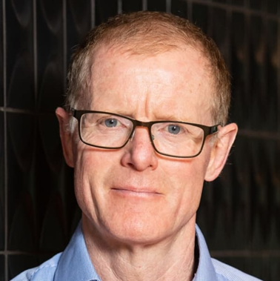

Professor Stephen Alexander
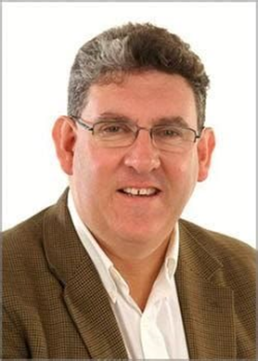 | Prof. Alexander specializes in Paediatrics at the Children's Hospital in Westmead. His focus is Child Health, Immune tolerance, Immunology, Nephrology, Transplantation.  He has been working with Harald Jueppner, Professor of Paediatric Nephrology at Harvard’s Mass. General Hospital in Boston to build a Sydney based team that is researching genetic factors involved in kidney disease.  The team has made major strides in understanding the genetics of such diseases, leading to identification of key contributing factors, publications on national genetic testing, and development of new treatments.  Harvard, through MGH and its Broad Institute, has been a leader in developing new treatment strategies for kidney disease, particularly in the area of DNA editing.  Alexander’s work during his visit will focus on developing new tools for diagnosing harmful mutations, strategies for evaluating such identified mutations, and development of new genetic therapies. The visit will also help maintain the relationship Australia’s paediatric nephrology community has built with MGH and Broad Institute.

